Acts 28 – Test Your Knowledge

- What was the name of the chief official of the island of Malta?
- Aristarchus
- Julius
- Publius
- Marcus

- How long did they stay on the island of Malta?
- 3 months
- 6 months
- 1 year
- 2 years

- How long did Paul stay with the believers in Puteoli?
- 2 days
- 3 days
- 7 days
- 14 days

- What prophet did Paul quote from in this chapter?
A. Zachariah
B. David
C. Elisha
D. Isaiah

- How long did Paul stay in Rome as a prisoner?
- 2 months
- 2 years
- 4 years
- 5 years

Bonus (5 Points): What was the name of the Roman Emperor at the end of the book of Acts? ______________________________________________________________

Grade: _____ (20 Points for each correct answer)

In Acts 27:21-44, Paul transitions from prisoner to spiritual leader during a perilous sea voyage from Crete, where a violent storm leaves the crew hopeless and fearing death. Despite the chaos, Paul remains steadfast in his faith, sharing a divine message from an angel that although the ship will be lost, all 276 aboard will survive. As the ship nears land, they take depth soundings and drop anchors, praying for daylight. When some sailors attempt to escape, Paul insists that survival depends on everyone staying together, prompting soldiers to cut the lifeboats loose. On the fourteenth day, Paul encourages the crew to eat and assures them of their safety, leading a shared meal that boosts morale. Spotting land, they attempt to beach the ship, but it runs aground and begins to break apart. Despite the soldiers’ initial plan to kill the prisoners to prevent escape, the commander spares Paul and the other prisoners and all aboard safely reach the island of Malta, fulfilling Paul’s prophecy.
Acts 28 (NLT)

Paul on the Island of Malta
¹ Once we were safe on shore, we learned that we were on the island of Malta. ² The people of the island were very kind to us. It was cold and rainy, so they built a fire on the shore to welcome us.
³ As Paul gathered an armful of sticks and was laying them on the fire, a poisonous snake, driven out by the heat, bit him on the hand. ⁴ The people of the island saw it hanging from his hand and said to each other, “A murderer, no doubt! Though he escaped the sea, justice will not permit him to live.” ⁵ But Paul shook off the snake into the fire and was unharmed. ⁶ The people waited for him to swell up or suddenly drop dead. But when they had waited a long time and saw that he wasn’t harmed, they changed their minds and decided he was a god.
⁷ Near the shore where we landed was an estate belonging to Publius, the chief official of the island. He welcomed us and treated us kindly for three days. ⁸ As it happened, Publius’s father was ill with fever and dysentery. Paul went in and prayed for him, and laying his hands on him, he healed him. ⁹ Then all the other sick people on the island came and were healed. ¹⁰ As a result we were showered with honors, and when the time came to sail, people supplied us with everything we would need for the trip.

Paul Arrives at Rome
¹¹ It was three months after the shipwreck that we set sail on another ship that had wintered at the island—an Alexandrian ship with the twin gods as its figurehead. ¹² Our first stop was Syracuse, where we stayed three days. ¹³ From there we sailed across to Rhegium. A day later a south wind began blowing, so the following day we sailed up the coast to Puteoli. ¹⁴ There we found some believers, who invited us to spend a week with them. And so we came to Rome.
¹⁵ The brothers and sisters in Rome had heard we were coming, and they came to meet us at the Forum on the Appian Way. Others joined us at The Three Taverns. When Paul saw them, he was encouraged and thanked God.
¹⁶ When we arrived in Rome, Paul was permitted to have his own private lodging, though he was guarded by a soldier.

Paul Preaches at Rome under Guard
¹⁷ Three days after Paul’s arrival, he called together the local Jewish leaders. He said to them, “Brothers, I was arrested in Jerusalem and handed over to the Roman government, even though I had done nothing against our people or the customs of our ancestors. ¹⁸ The Romans tried me and wanted to release me, because they found no cause for the death sentence. ¹⁹ But when the Jewish leaders protested the decision, I felt it necessary to appeal to Caesar, even though I had no desire to press charges against my own people. ²⁰ I asked you to come here today so we could get acquainted and so I could explain to you that I am bound with this chain because I believe that the hope of Israel—the Messiah—has already come.”
²¹ They replied, “We have had no letters from Judea or reports against you from anyone who has come here. ²² But we want to hear what you believe, for the only thing we know about this movement is that it is denounced everywhere.”
²³ So a time was set, and on that day a large number of people came to Paul’s lodging. He explained and testified about the Kingdom of God and tried to persuade them about Jesus from the Scriptures. Using the law of Moses and the books of the prophets, he spoke to them from morning until evening. ²⁴ Some were persuaded by the things he said, but others did not believe. ²⁵ And after they had argued back and forth among themselves, they left with this final word from Paul: “The Holy Spirit was right when he said to your ancestors through Isaiah the prophet,
²⁶ ‘Go and say to this people:
When you hear what I say,
you will not understand.
When you see what I do,
you will not comprehend.
²⁷ For the hearts of these people are hardened,
and their ears cannot hear,
and they have closed their eyes—
so their eyes cannot see,
and their ears cannot hear,
and their hearts cannot understand,
and they cannot turn to me
and let me heal them.’
²⁸ So I want you to know that this salvation from God has also been offered to the Gentiles, and they will accept it.”
³⁰ For the next two years, Paul lived in Rome at his own expense. He welcomed all who visited him, ³¹ boldly proclaiming the Kingdom of God and teaching about the Lord Jesus Christ. And no one tried to stop him.

Verses 1 thru 3 (The Island of Malta)
When the soldiers, sailors and prisoners made it to the shore, they were cold, wet and very tired from their ordeal. The local inhabitants of the island came out and built them a fire to dry themselves out and warm them up. The island that they had landed on was called Malta and it is located about 40 miles south of Sicily. The people of the island were from a Phoenician background, but the island was ruled by the Romans.
It was still raining from the storm, and Paul gathers some wood for the fire. Apparently, a snake was in the wood that Paul had picked up, and when he went to put it on the fire, it came out and bit Paul on the hand. Had Paul not been through enough already. Why would God allow this snake to bite him?

Verses 4 thru 6 (Who is Watching You)
The locals see the viper hanging off of Paul’s hand, and they know that this snake has given him a fatal bite. The natives were very superstitious, and they decided that even though Paul had survived the storm he was now condemned to die by a snakebite. Because Paul was a prisoner, they say he must be a murderer, and this snake was used to punish him.
What was Paul’s reaction to the snakebite? Did he scream and curse? Did he question why God would allow this snake to bite him. Did he complain about all of the things he had gone through and now he had been bitten? The apostle simply shakes it off back into the fire and continues about his business. Did he know that they were watching him? Would it matter if someone was watching you?
These locals knew that this poisonous snake would soon make Paul start to swell up, and they watched him to see how fast he would die. 10 minutes, 30 minutes, maybe even an hour go by, but Paul is unaffected by the snake. Once again, God had protected him from death, and he didn’t have any effects from the bite. Now the locals change their mind and decide that Paul isn’t a murderer, but now they think he is a god! Who is watching you as you go through your trials? Remember that you are the only Bible that many people will ever read? Is it fair to judge a book by its cover?

Verses 7 thru 9 (Healing Power)
There was a large estate near where they had swam ashore and the owner of the estate was a man named Publius. Publius is a Roman name, and we are told that he was the chief official of the island. Publius is kind to the shipwrecked crew, and he invites them to stay at his home for three days. Publius’ father was sick, and he had a high fever and severe diarrhea known as dysentery. Although this condition is easily cured today with antibiotics, during this time it was often fatal, especially in elderly people.
Paul learns of his sickness and uses the opportunity to witness to these lost people. Paul goes into the father’s room, lays his hands on him and prays for the man to be healed. I wonder what Publius thought that Paul was doing? I’m sure he had heard about Paul surviving the snakebite and now this mighty man of God was attempting to heal his father. Paul’s prayer is answered, and the man is miraculously healed. The word spread fast around the island, and soon everyone was bringing the sick to be healed by Paul.

Verses 10 thru 14 (From Malta to Italy)
After evangelizing on the island of Malta for three months, they find another grain ship from Alexandria that is headed to Italy. The local inhabitants of the island wanted to honor Paul for his work, and they gave them all the supplies that they needed for the rest of their journey. This Egyptian ship that they were boarding had symbols of the twin gods Castor and Pollux affixed to the ship. These gods in Greek and Roman mythology were considered guardian angels for sailors. Paul already had a guardian angel who was watching over him on this trip, and he had no use for these myths.
The ship had probably spent the winter in Malta and now it is getting closer to spring, and time to sail onto Italy. The ship leaves Malta and makes its first stop at the port of Syracuse on the island of Sicily. They stayed there for three days and then took a short trip to Rhegium, which is on the very southern tip of Italy. The next day they left Rhegium and continued up the western coast of Italy until they came to the port of Puteoli near modern day Naples where they would end their sailing adventure.
In Puteoli they found a group of believers who invited them to their homes, and they stayed there for a week. This must have been a great sight for Paul to find these believers in Italy. Although Paul had never been to Italy, this was proof that the gospel message had spread beyond his missionary journeys and was already thriving in Italy.
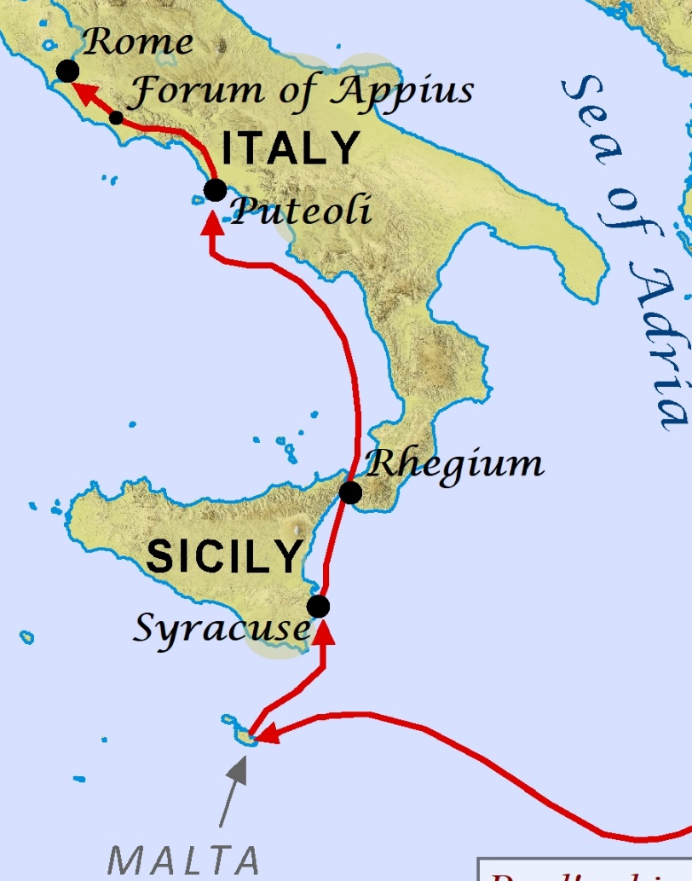

Verses 15 and 16 (Joined by other Believers)
The rest of their journey would now be across land, and it was about 120 miles by land to Rome. They followed a Roman road called the Appian Way that was made of volcanic rock and covered 362 miles along the western coast of Italy. Portions of this road are still in use today in its original form.
When they reached a place called the Forum about 40 miles south of Rome, they were met by more believers who had come from Rome to meet Paul on his journey. About 10 miles farther up the road they were met by another group of believers. How encouraging this must be to have a large group of brothers and sisters accompany Paul as he walked into the city like a triumphant warrior and not as a prisoner bound in chains.
Once in the city of Rome, Paul was allowed to stay in his own private residence with a Roman guard. The fact that he was allowed to stay in a home and not confined to a prison dungeon, shows how much respect that these Roman soldiers had for Paul. The prisoners were now safe in the city of Rome, and the soldiers could finally return home themselves after completing their mission.

Verses 17 thru 20 (Church at Paul’s House)
Three days after Paul had arrived in Rome, he did what he had always done on his missionary journeys. He called all of the Jewish leaders together and brought the gospel message to them first. He explains how he had been falsely arrested in Jerusalem and turned over to the Romans to stand trial.
Paul tells them that he appealed to Caesar even though he had nothing against his Jewish brethren. He has a true heart for the Jews to come to know Jesus Christ, and he had called them to his home to explain that the Messiah has already come to Israel. Paul probably expected that the Jews from Jerusalem had sent letters or representatives to Rome like they had in Caesarea.

Verses 21 thru 29 (No News is Good News)
The Jewish leaders had not heard anything about Paul’s trial, and they were very interested in hearing what Paul had to say. It seems that all that they new about Jesus, was that it was a name that caused division everywhere it was spoken, but they had no knowledge of why it was causing problems.
They setup a date to meet with the rest of the local Jews, so they could hear more about Paul’s message concerning the Messiah. On the appointed day, a large crowd of both Jews and Gentiles gathered at Paul’s house. Paul probably could not fit everyone inside, and he may have given his address from a porch or balcony to the curious crowd.
Personal experience with Christ can be a good witnessing tool, but Paul knew that he could only reach this crowd by proving that Jesus was the Messiah using the words of the Law and the Prophets (Old Testament). This was not a 30-minute sermon, but an all-day event that lasted from morning until evening. We struggle to sit still for one hour to hear a sermon, but Paul was able to keep this crowd captivated for 8-12 hours. What a sermon that must have been!
As had always been the case and still is today, some believed and some refused to accept that Jesus is the Messiah. In Paul’s final words that day, he quoted from Isaiah 6:9-10 and explained how the prophet had looked into the future and saw this day where the people of Israel would reject the Messiah. As a result of them rejecting the Messiah, the Gospel message would be offered to the Gentiles, and they would accept Jesus as the Messiah.

Verses 30 and 31 (Preaching from Home)
The book of Acts closes with these two promising verses, but sadly Luke does not tell us what happened at Paul’s trial with Caesar. We are told that Paul spent the next two years in Rome boldly preaching the Gospel message from his home to anyone who would listen. Paul had great freedom to spread the message of Jesus Christ, and no one tried to stop him. This is in great contrast to the rest of his missionary journeys, where he always faced opposition and in most cases was run out of town or had assassination attempts on his life.
Acts Final Exam on January 7th

