Acts Chapter 16 – Test Your Knowledge

- What new person joined Paul on his missionary journey in this chapter?
- John Mark
- A Roman Jailer
- Lydia
- Timothy

- Where did Paul meet Lydia?
- A riverbank near Philippi
- At her house in Thyatira
- At the church in Lystra
- On the road near Troas

- Which place did Paul and Barnabas not go to in this chapter?
- Neapolis
- Derbe
- Bithynia
- Troas

- Around midnight, an angel came and let Paul and Silas out of prison?
A. True
B. False

- Who got saved in this chapter?
- Slave Girl
- A Roman Jailer
- City Officials
- Timothy

Bonus (20 Points): Which one of the Seven Churches in Revelations is mentioned in this chapter? ____________

Grade:_____ (20 Points for each correct answer)

The Acts of the Apostles – Chapter 16

Last week the church at Antioch had sent Paul and Barnabas back to Jerusalem to settle a dispute about whether Gentile believers had to be circumcised to be saved. The Council at Jerusalem was led by Peter and James, and James made the final decision that the Gentiles did not have to be circumcised. James did say that they needed to follow some basic kosher laws to prevent offending their Jewish brothers and abstain from sexual immorality. A letter was written to the Gentiles with this decree, and great joy spread throughout the region of Antioch when it was read. Paul and Barnabas decide to go on another missionary journey, but they have a sharp disagreement over taking John Mark and decide to split up and go different directions. Barnabas takes John Mark and sails to Cyprus, and Paul takes Silas and goes throughout Syria and Cilicia.

Paul’s Second Missionary Journey (NLT)
¹ Paul went first to Derbe and then to Lystra, where there was a young disciple named Timothy. His mother was a Jewish believer, but his father was a Greek. ² Timothy was well thought of by the believers in Lystra and Iconium, ³ so Paul wanted him to join them on their journey. In deference to the Jews of the area, he arranged for Timothy to be circumcised before they left, for everyone knew that his father was a Greek. ⁴ Then they went from town to town, instructing the believers to follow the decisions made by the apostles and elders in Jerusalem. ⁵ So the churches were strengthened in their faith and grew larger every day.

A Call from Macedonia
⁶ Next Paul and Silas traveled through the area of Phrygia and Galatia, because the Holy Spirit had prevented them from preaching the word in the province of Asia at that time. ⁷ Then coming to the borders of Mysia, they headed north for the province of Bithynia, but again the Spirit of Jesus did not allow them to go there. ⁸ So instead, they went on through Mysia to the seaport of Troas.
⁹ That night Paul had a vision: A man from Macedonia in northern Greece was standing there, pleading with him, “Come over to Macedonia and help us!” ¹⁰ So we decided to leave for Macedonia at once, having concluded that God was calling us to preach the Good News there.

Lydia of Philippi Believes in Jesus
¹¹ We boarded a boat at Troas and sailed straight across to the island of Samothrace, and the next day we landed at Neapolis. ¹² From there we reached Philippi, a major city of that district of Macedonia and a Roman colony. And we stayed there several days.
¹³ On the Sabbath we went a little way outside the city to a riverbank, where we thought people would be meeting for prayer, and we sat down to speak with some women who had gathered there. ¹⁴ One of them was Lydia from Thyatira, a merchant of expensive purple cloth, who worshiped God. As she listened to us, the Lord opened her heart, and she accepted what Paul was saying. ¹⁵ She and her household were baptized, and she asked us to be her guests. “If you agree that I am a true believer in the Lord,” she said, “come and stay at my home.” And she urged us until we agreed.

Paul and Silas in Prison
¹⁶ One day as we were going down to the place of prayer, we met a slave girl who had a spirit that enabled her to tell the future. She earned a lot of money for her masters by telling fortunes. ¹⁷ She followed Paul and the rest of us, shouting, “These men are servants of the Most High God, and they have come to tell you how to be saved.”
¹⁸ This went on day after day until Paul got so exasperated that he turned and said to the demon within her, “I command you in the name of Jesus Christ to come out of her.” And instantly it left her.
¹⁹ Her masters’ hopes of wealth were now shattered, so they grabbed Paul and Silas and dragged them before the authorities at the marketplace. ²⁰ “The whole city is in an uproar because of these Jews!” they shouted to the city officials. ²¹ “They are teaching customs that are illegal for us Romans to practice.”
²² A mob quickly formed against Paul and Silas, and the city officials ordered them stripped and beaten with wooden rods. ²³ They were severely beaten, and then they were thrown into prison. The jailer was ordered to make sure they didn’t escape. ²⁴ So the jailer put them into the inner dungeon and clamped their feet in the stocks.
²⁵ Around midnight Paul and Silas were praying and singing hymns to God, and the other prisoners were listening. ²⁶ Suddenly, there was a massive earthquake, and the prison was shaken to its foundations. All the doors immediately flew open, and the chains of every prisoner fell off! ²⁷ The jailer woke up to see the prison doors wide open. He assumed the prisoners had escaped, so he drew his sword to kill himself. ²⁸ But Paul shouted to him, “Stop! Don’t kill yourself! We are all here!”
²⁹ The jailer called for lights and ran to the dungeon and fell down trembling before Paul and Silas. ³⁰ Then he brought them out and asked, “Sirs, what must I do to be saved?”
³¹ They replied, “Believe in the Lord Jesus and you will be saved, along with everyone in your household.” ³² And they shared the word of the Lord with him and with all who lived in his household. ³³ Even at that hour of the night, the jailer cared for them and washed their wounds. Then he and everyone in his household were immediately baptized.³⁴ He brought them into his house and set a meal before them, and he and his entire household rejoiced because they all believed in God.
³⁵ The next morning the city officials sent the police to tell the jailer, “Let those men go!” ³⁶ So the jailer told Paul, “The city officials have said you and Silas are free to leave. Go in peace.”
³⁷ But Paul replied, “They have publicly beaten us without a trial and put us in prison—and we are Roman citizens. So now they want us to leave secretly? Certainly not! Let them come themselves to release us!”
³⁸ When the police reported this, the city officials were alarmed to learn that Paul and Silas were Roman citizens. ³⁹ So they came to the jail and apologized to them. Then they brought them out and begged them to leave the city. ⁴⁰ When Paul and Silas left the prison, they returned to the home of Lydia. There they met with the believers and encouraged them once more. Then they left town.
Verses 1 thru 5 (Timothy Joins the Journey)‬‬‬‬‬
Paul returns to Derbe and Lystra finds a young man named Timothy who has a Jewish mother and a Greek father. Paul refers to Timothy as a disciple in this chapter, and would later write about him in 1 Cor.4:17 as “my beloved and faithful child in the Lord.” This reference to Timothy as Paul’s “child” probably means that he was actually saved when Paul first visited Lystra about 5 years earlier. Paul is so impressed with this young man that he wants him to join him and Silas on their missionary journey. Sometimes when God removes one person from your life (Barnabas), he replaces them with another (Timothy).
By telling us that his mother was a Jew and his father was a Greek, we find out that Timothy is a child of mixed race. According to the Jewish laws, a child was determined to be a Jew if his mother was Jewish and not whether his father was a Jew. We are also told that his mother (Eunice) was a Christian believer, and we later find out that his grandmother (Lois) was also a believer (2 Tim. 1:5). From the language in this chapter, we are led to believe that his Greek father was not a believer or at least he wasn’t at this time.
Paul now does something that seems contrary to everything he has fought for in the previous chapter. Paul takes Timothy and gets him circumcised even though he had “vehemently” disagreed with circumcision being required for salvation. Did Paul think Timothy needed to be circumcised to be saved?
Although it was not said in this chapter, Paul did not force Timothy to be circumcised. I’m sure Paul thoroughly explained his mission to Timothy, and it was ultimately Timothy’s decision to be circumcised. Timothy made a sacrifice so he would not offend the Jews as they went into the synagogues witnessing to other Jews. He put his pride aside and decided to love his brothers enough not to offend them.
Paul and his companions now travel from town to town in the area of Galatia and revisit the churches that Paul started on his first missionary journey. In each town, they read the letter that the Council at Jerusalem sent to the Gentile believers. Paul takes the time to instruct the believers about the decision that the apostles and elders had made and help to strengthen them. Due to this good news, the churches in those areas continued to grow.
Verses 6 thru 10 (Guided by the Holy Spirit)‬‬‬‬‬
Paul decides to go down to Asia minor and he was probably intending to visit the capitol city of Ephesus. These highly populated areas were places where they could have had a large impact, and seen thousands of people get saved. But the Holy Spirit prevented them from going in that direction. We do not know exactly why they were prevented from going there, but we must learn to trust the Holy Spirit and go where and when he calls us. God’s plans are better than our plans, and anytime we try to “help” God by doing it our way we are bound to get in trouble. Although the Holy Spirit did not tell Paul where to go at this point, He did make it clear where they could not go.
Since Paul was not allowed to go down south, he now decides to go up north. As they are traveling through the area of Mysia, Paul decides to go up to the coast of the Black Sea to an area known as Bithynia. But once again we are told that the Spirit of Jesus prevented them from going that way. This is the only time in the New Testament where the term “Spirit of Jesus” is used, but not all Bible translations are the same. Do not be confused or ask if this is a different spirit than the Holy Spirit. They are all one in the same. Whether He is called the Spirit, Holy Spirit, Holy Ghost or the Spirit of Jesus, these are all names for the third person of the Trinity.
Paul had come from the south and then he tried to go north, but both ways had been blocked by the Holy Spirit. So which way to go now? Go west young man, go west. Paul heads west to the port city of Troas and as he is sleeping, he sees a vision of a man in Macedonia begging him to come and help them. Paul realizes that this is not just a dream, but rather it was a vision given to him as direction by the Holy Spirit.
Verses 11 thru 15 (Lydia in Philippi)‬‬‬‬‬
Paul and his “three” companions book passage on a ship and take a short trip over to Samothrace, and then on to Neapolis in Macedonia. Three? Who was the third companion with Paul? Up to this point in the book of Acts, the author has always used the third person pronouns like “they” and “them”, but in verse 11 he says “we” indicating that at this point in the story that Luke is now part of the missionary journey.
They now travel on to the city of Philippi which is a major city in the region of Macedonia, and they stayed in that city for some time. Paul learns that there is a group of Jewish women who meet regularly for prayer on a river bank outside of town, and he decides to go visit them on the Sabbath. Apparently there were no synagogues in Philippi, and there seems to be a lack of Jewish men as well. There had to be at least ten Jewish men to form a synagogue and have a quorum. These ladies did not need a man to lead them in prayer and worship, and neither do you.
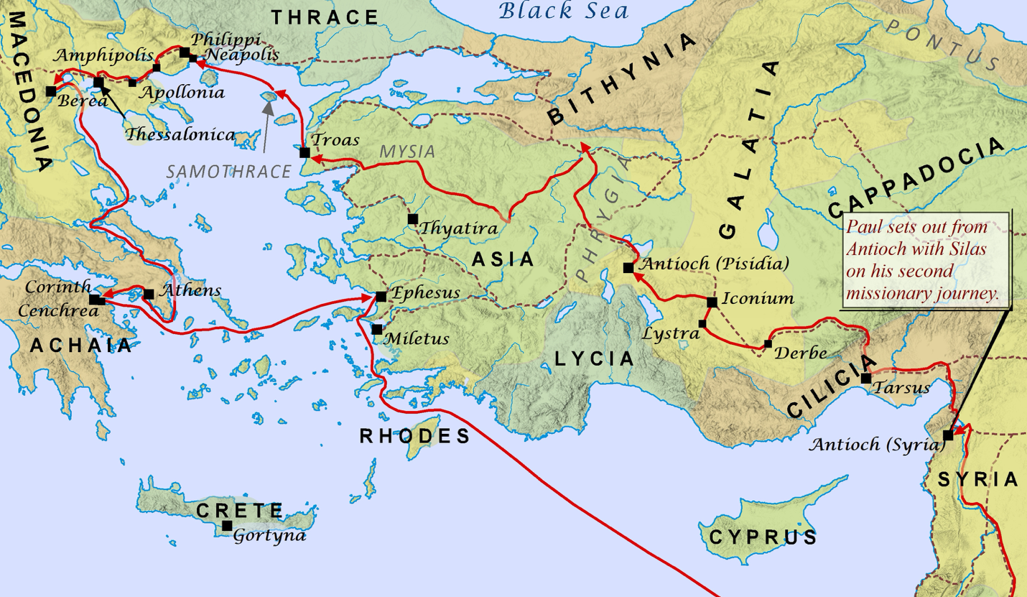
Paul meets a lady named Lydia who is a business woman who made expensive purple cloth. We are told that Lydia was originally from Thyatira, and that is one of the seven churches mentioned in the book of Revelations. Paul preaches the gospel to the ladies and Lydia and her entire household get saved. Lydia is the first person in what is today modern-day Europe to receive salvation. Since Lydia is a woman of influence and considerable wealth, she invites the missionaries to come and stay in her home.

Verses 16 thru 24 (Freeing a Slave Girl)‬‬‬‬‬
There was a slave girl in Philippi who was possessed by a demon. This demon gave her the power to foretell the future, and her owners used this to exploit the girl and make money. Much like fortune tellers and psychics today, they are driven by evil spirits and often do it to make money. People often refer to these people as harmless and only see it as a form of entertainment. Don’t be fooled! Some of these people are faking it just to make money, but others are empowered by the will of demonic spirits. Stay away from these evil things and keep them out of your house!
People who were filled with demons often recognized Jesus as the Son of God (Mark 1:24, Mark 5:7, Luke 4:41, Luke 8:28). This demonic spirit recognized Paul and his companions as “servants of the Most High God.” This demon even told people that they were here to tell people how to be saved. I don’t know why these evil spirits would recognize Jesus or the disciples in that way, but this slave girl kept following Paul and the other believers and saying this every day. Paul finally gets tired of hearing the demon speak. Paul commands the demon to come out of her using the name of Jesus. The girl is instantly freed from the demon, and she is no longer controlled by its power. Since the girl’s ability to predict the future came from the demon, she no longer has the ability to tell fortunes and her profitability to her owners is stripped away.
The owners or masters as they are referred to in these versus are furious that they have lost their source of income, and immediately attack the disciples. They drag them into the city marketplace and find the authorities so they can press charges against the disciples. The masters accuse the disciples of causing trouble and teaching customs that are against Roman law. What Roman law had they broken by casting out a demon? What trouble had they started?
In a makeshift trial, the city officials find the disciples guilty, and have them stripped naked and beaten with wooden rods. Later on in 2 Cor. 11:25, Paul would recount being beaten 3 times with rods and this was obviously one of those times. After they finish beating the disciple, they give them to the jailer with instructions to put them in jail and make sure they don’t escape. Their punishment continues inside the jail. They are placed in the inner prison cell and their legs are placed in stocks. These stocks were wooden beams fastened together and designed to spread the legs wide apart in a painful position. These stocks were fastened to the walls with chains to further ensure that the prisoners could not escape.
Verses 25 thru 28 (Praising God in the Midst of the Trial)‬‬‬‬‬
In the midst of this horrible trial, we find Paul and Silas inside the dungeon in utter darkness. The soreness of their beating was probably unbearable, and the stocks would not allow them to find a comfortable position to rest. How would you have reacted if you were subjected to this same torture? We would likely have been whining and crying like a 2 year old who had just fell and scraped their knee. But not these two warriors for Christ! We learn that during the darkest hours of their struggles, that they are praying and praising God! And they are not alone. We are told that the other prisoners are listening and seeing the faithfulness of these men who don’t deserve to be in the prison. When you find yourself in a trial, stop and ask God what he is trying to teach you or the people who are watching you.
As they are praising God in the dungeon God shakes the foundation of the prison with an earthquake, and all of the doors fly open and everyone’s chains fall off. The jailer had been asleep, but he is awakened by the mighty quake to find that the gates of the prison were wide open. Since it was dark in the prison and he could only see the open prison gates, he assumed that all of the prisoners had escaped. According to Roman law, if a prisoner escapes the life of the guard is required. Knowing this the jailer pulls out his own sword to commit suicide. But Paul calls to him and tells him that they are all here. Not just Paul and Silas, but all of the prisoners had stayed even though they could have just walked out of the jail and escaped.
Verses 29 thru 34 (What must I do to be Saved?)‬‬‬‬‬
The jailer hears the voice of Paul, but he still can’t believe that all of the prisoners are still there. He calls for lights from some other guards and to his great surprise, all of the prisoners are still sitting inside the prison even though the gates are open and their chains are gone. He takes Paul and Silas outside the prison and into his home. Seeing the great faith of these two men, the jailer quickly realizes that he wants to be saved. Paul doesn’t make it complicated and he simply says, “Believe in the Lord Jesus, and you will be saved, you and your household.” The jailer and his household believe in Jesus, and all of them were baptized. The jailer treats the wounds that they have received from the beating and from the stocks, and he prepares a meal for them. The jailer feeds them food, and Paul feeds him the Word of God.
Verses 35 thru 40 (Roman Citizenship)‬‬‬‬‬
The next morning the city officials send word to the jailer to let Paul and Silas go. I guess they thought that a severe beating and a night in jail was enough punishment for them. Remember that Paul is a Roman citizen, and it was illegal for them to be punished without a trial. Since both Paul and Silas looked like Jews, they probably never imagined that they were also Roman citizens. Roman citizenship was a coveted thing, and the penalty the city officials would have received for violating their rights would have been severe. So why didn’t Paul tell them that they were Roman citizens and avoid the beating? Wouldn’t that have been the wise thing to do?
Now that Paul has been able to witness to the jailer, his family and all of the other inmates, he decides that he will assert his rights as a Roman. When they come to let Paul out of jail, he tells them that he will not leave without the city officials coming to the jail and apologizing. I’m sure when the message got back to the city officials that they were Romans, they probably immediately panicked and thought they were the ones who were going to be punished. They go to the jail and plead with the disciples to please leave the city. Paul and Silas agree to leave, but not before they go back to Lydia’s house and tell them about everything that had happened.
James 1:2-4 (NASB) Consider it all joy, my brothers and sisters, when you encounter various trials, knowing that the testing of your faith produces endurance. And let endurance have its perfect result, so that you may be perfect and complete, lacking in nothing.
Read Chapter 17 before our next class.

