John Chapter 3 – Part 2 - Test Your Knowledge

- Where was John the Baptist baptizing people at in this chapter?
- The Jordan River
- The Red Sea
- The Pool of Bethesda
- The area of Aenon

- John the Baptist was irritated at the success Jesus and his disciples were having in baptizing people.
- True
- False

- What did John the Baptist say that would stay on people who did not believe in the Son?
- Spiritual blessings
- God’s wrath / judgement
- Evil spirits
- Endless chances to repent

- The Father loves the __________.
- Moon
- Stars
- Son
- None of the above

- Anyone who believes in God’s Son has ___________.
- Eternal life
- Peace on earth
- Abundant wealth
- Many sorrows

Bonus (20 Points): How many people did Jesus baptize?
______________

Grade: _______ (20 Points for each correct answer)

Recap from the Last Class
Last week we covered the first half of chapter 3. We met Nicodemus, a Pharisee and influential member of the Sanhedrin who appears only in the Gospel of John. He first visits Jesus at night seeking to understand His miracles and teachings, addressing Him respectfully as “Rabbi”. Jesus responds by explaining that no one can enter God’s kingdom without being “born again” and clarifies that this new birth is a work of “water and the Spirit”, echoing God’s promise of inner cleansing and renewal in Ezekiel 36:25–27. Though initially confused about spiritual rebirth, Nicodemus exemplifies a genuine seeker whose rigid religious background made Jesus’ teaching difficult to grasp. His growing conviction later becomes evident when he challenges the Sanhedrin’s unlawful rush to condemn Jesus, insisting that the Law requires a fair hearing. After the crucifixion, Nicodemus openly identifies with Jesus by assisting Joseph of Arimathea in providing an extravagant burial for Jesus. He brought seventy-five pounds of myrrh and aloes, a gesture symbolizing royal honor and gave Him a kings burial. Jesus’ teaching culminates in the proclamation that the Son of Man must be lifted up like Moses’ bronze serpent, offering eternal life to all who believe, ultimately summarized in the well-known declaration of God’s love and saving purpose in John 3:16–17. Jesus concludes by revealing that although the world prefers darkness, He came as the light exposing sin and calling people into truth and repentance.
John – Chapter 3 (NLT)

John the Baptist Exalts Jesus
²² Then Jesus and his disciples left Jerusalem and went into the Judean countryside. Jesus spent some time with them there, baptizing people.
²³ At this time John the Baptist was baptizing at Aenon, near Salim, because there was plenty of water there; and people kept coming to him for baptism. ²⁴ (This was before John was thrown into prison.) ²⁵ A debate broke out between John’s disciples and a certain Jew over ceremonial cleansing. ²⁶ So John’s disciples came to him and said, “Rabbi, the man you met on the other side of the Jordan River, the one you identified as the Messiah, is also baptizing people. And everybody is going to him instead of coming to us.”
²⁷ John replied, “No one can receive anything unless God gives it from heaven. ²⁸ You yourselves know how plainly I told you, ‘I am not the Messiah. I am only here to prepare the way for him.’ ²⁹ It is the bridegroom who marries the bride, and the bridegroom’s friend is simply glad to stand with him and hear his vows. Therefore, I am filled with joy at his success. ³⁰ He must become greater and greater, and I must become less and less.
³¹ “He has come from above and is greater than anyone else. We are of the earth, and we speak of earthly things, but he has come from heaven and is greater than anyone else. ³² He testifies about what he has seen and heard, but how few believe what he tells them! ³³ Anyone who accepts his testimony can affirm that God is true. ³⁴ For he is sent by God. He speaks God’s words, for God gives him the Spirit without limit. ³⁵ The Father loves his Son and has put everything into his hands.³⁶ And anyone who believes in God’s Son has eternal life. Anyone who doesn’t obey the Son will never experience eternal life but remains under God’s angry judgment.”
Verse 22 (Baptizing the People)‬‬‬‬‬
In verse 22, we find that Jesus and his disciples started to baptize people in the area of Judea. No specific location was given, and that may be because Jesus and his disciples moved around from place to place baptizing people as they came to repentance. Although this text might lead you to think that Jesus Himself was baptizing people due to the statements in verse 22 and 26, we will find out in the next chapter (verse 4:2) that John clarifies that Jesus himself did not baptize anyone. It was Jesus’ disciples that were baptizing people and not the Messiah Himself. Why do you think that Jesus did not baptize people? If Jesus did not baptize anyone, who baptized His disciples?
Verses 23 thru 26 (The Baptism Debate)‬‬‬‬‬
John the Baptist and his disciples continued to baptize people at Aenon. The word Aenon in Hebrew means “many springs” and we know that it was near a place called Salim. There is some debate over where this area is at, but the map on the next page shows the approximate location. It is about seven miles south of modern day Bethshan (Sythopolis). The map also shows the other locations where John the Baptist was baptizing people during his ministry.
While John the Baptist was ministering in this area, the Bible says that some of John the Baptist disciples and “some Jews” had a debate over purification or ceremonial cleansing. These “Jews” were probably the Pharisees that John the Apostle mentions in John 4:1 that heard “Jesus made and baptized more disciples than John.” Although we don’t know what the exact nature of this debate was, apparently it centered around baptism and who was doing the baptizing. John the Baptist disciples seem irritated that Jesus and his disciples were also baptizing people, and they were concerned that more people were going to Jesus for baptism than to John the Baptist. They were proud of the ministry that they had started and were disappointed to see it start to dwindle away. Was this fair of them to be upset?
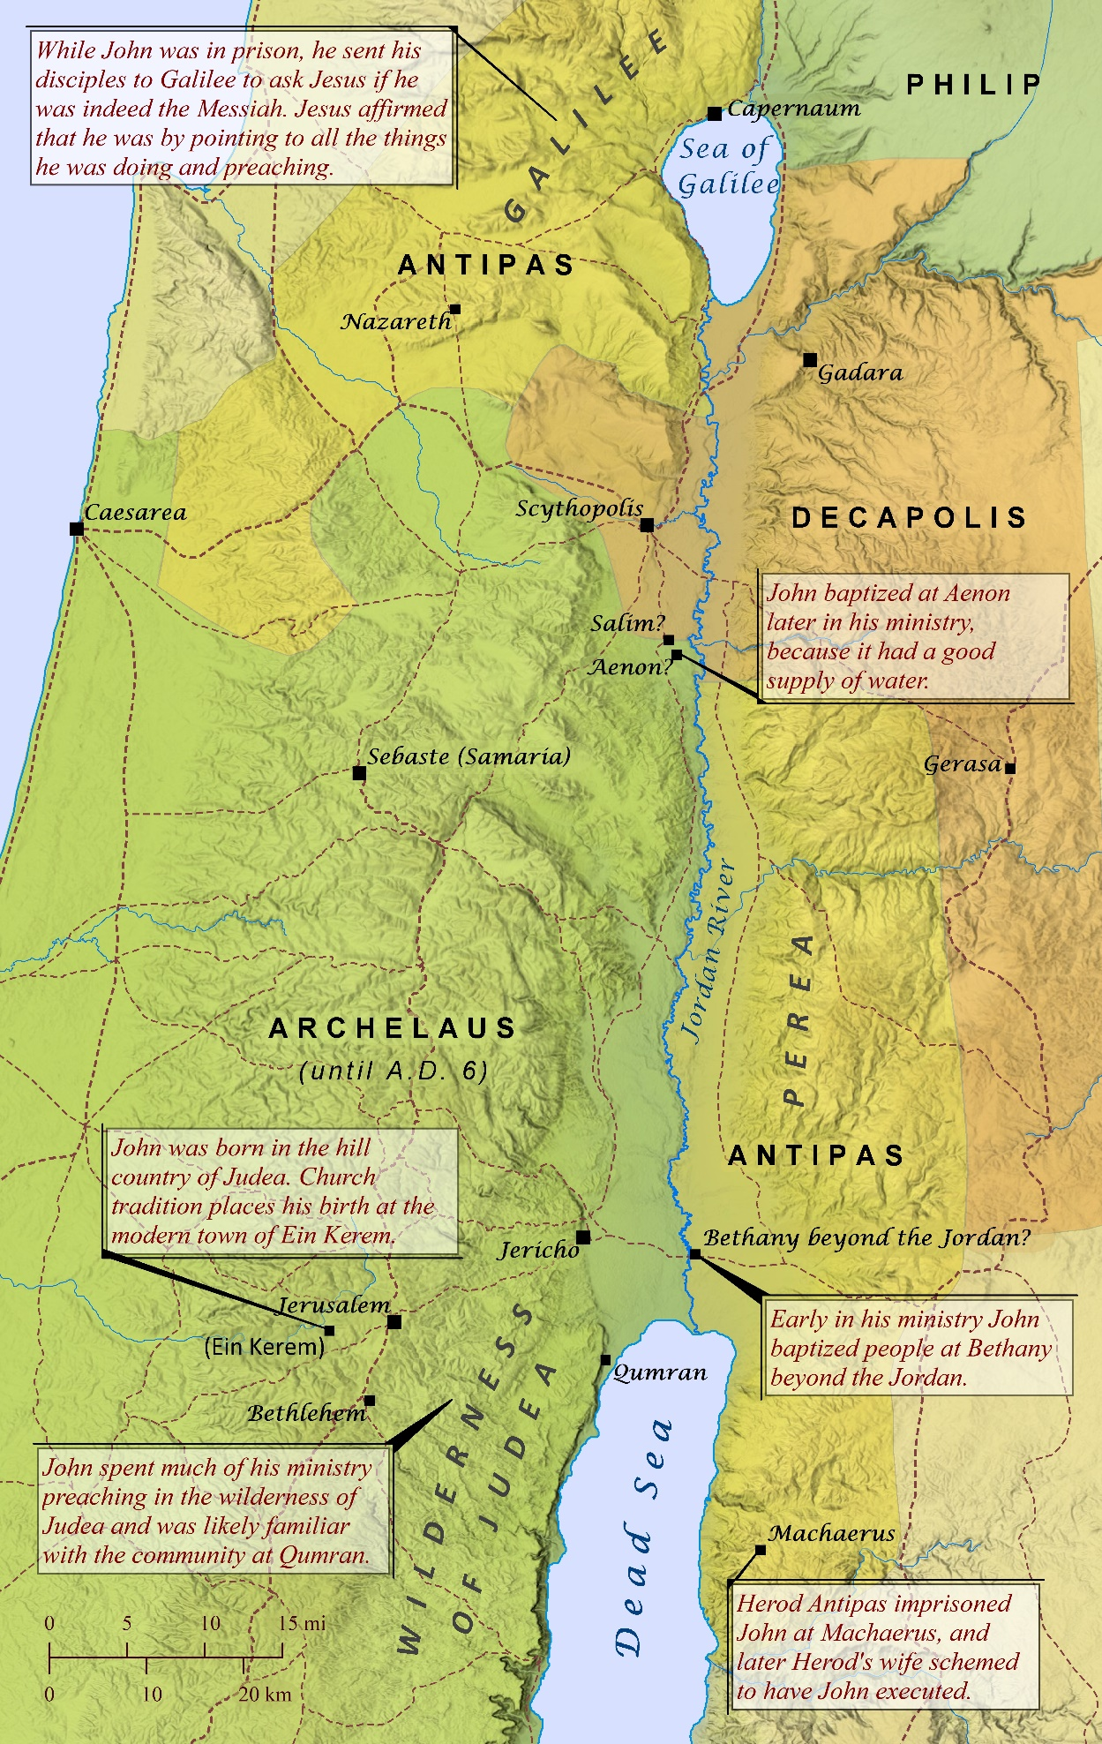
Verses 27 thru 30 (John’s Joy in Jesus’ Ministry)‬‬‬‬‬
John the Baptist answers his disciples in a way that they probably did not expect. He tells them the truth that everything (including his ministry) had been given to him from God. John’s message was really that this ministry did not belong to him or to his disciples. It was God’s ministry and it was succeeding even though it appeared to be failing to his disciples. John reminded his disciples that he was not the Messiah, and that his whole purpose was to “prepare the way” and not “be the way.”
John was overjoyed to see Jesus’ ministry thriving and he was happy that he could be part of His success. John’s ministry had prepared the hearts of the people, and he knew that he would need to fade away for Jesus to have complete success. John the Baptist said in verse 30, “He must become greater and greater, and I must become less and less.” We should always try to understand God’s purpose for us in His master plan and be willing to accept whatever God wants us to do. What if that meant stepping down from your position as a leader to give someone else a chance? Would you “happily” step down so that someone else could take your position? Would you be willing to serve them without being negative? Would you do it if God had clearly told you that this was His plan? What if you refused to step down and you maintained your current role?
Verses 31 thru 33 (Testimony about Jesus)‬‬‬‬‬
There is some debate about whether or not verses 31-36 are still the words of John the Baptist or whether they are the words of John the Apostle. The NIV puts closing quotation marks at the end of verse 30, insinuating that it was the end of John the Baptist message. The NLT, AMP, NASB and others reopen the quotations at the beginning of verse 31 and close them out at the end of the chapter indicating that this was also the words of John the Baptist as well. The KJV does not use any quotation marks in the entire Bible as they were not commonly used when it was printed in 1611. Regardless of who is speaking these words, the meaning of this passage of scripture remains unchanged.
In verse 31 through 33 Jesus is proclaimed to be from Heaven above. Although He was born here on earth, He came from Heaven and came down to earth. Jesus is not just a mere mortal man, but rather he is God and He dwelt here on earth in a humanly body. He was fully God and fully man all at the same time. Jesus’ message came from the Father in Heaven, and no one has ever spoken with the same authority that Jesus had. He spoke with and continues to speak with this authority today, but most people still chose to reject His message. By accepting Jesus as Lord and Savior of our life, we are also accepting that His message was/is from God the Father.

Verses 34 thru 36 (The Father Loves the Son)‬‬‬‬‬
These verses emphasize the relationship between the Father and the Son. The Son only speaks what the Father tells Him too and They speak as one voice. The Father loves His one and only Son and He has entrusted everything into His hands. This includes me and you. It includes the drunkard and the prostitute. It includes our government and local leaders both here and abroad. Everything has been entrusted to Him, and it is our responsibility to share His words with anyone who will listen. All who call upon the name of the Lord will be saved and have eternal life, but unfortunately many will deny and even curse Him. Just because they deny Him, ignore Him and curse Him, this does not change the fact that He still loves them. He loved us so much that he does not force us to accept Him, but he leaves that choice up to us.
Unfortunately, those who do not accept Jesus remain under God’s wrath, and they will not spend eternity in Heaven. Instead, they will spend eternity in Hell and the Lake of Fire where there is constant torment. Keep this in mind the next time you are questioning whether you should go witness to someone or not. You might get rejected or they may call you names, but if they do, they are no worse off than before and you have only suffered a small amount. But what if they hear your message and accept it or if they simply go home and think about it a little more. You may have planted the seed of faith that will one day lead them to believe in Jesus. What if you are the only person who ever has that chance to witness to them. What if it was your lost son or daughter? Would you want me to witness to them, or should I just walk away?
Take a few minutes and write down the list of people who you would want someone else to witness too. ________________________________________________________________________________________________________________________________________________________________________________________________________________________________________________________________________________________

