Acts Chapter 27 – Test Your Knowledge

- What was the name of the Roman officer who was in charge of Paul in this chapter?
- Claudius
- Aristarchus
- Cornelius
- Julius

- Where did they board the ship to start this trip to Rome?
- Sidon
- Fair Haven
- Caesarea
- Myra

- Which harbor did the crew want to spend the winter?
- Fair Haven
- Phoenix
- Myra
- Cnidus

- Which direction was the wind blowing when they left Fair Haven?
A. From the North
B. From the South
C. From the East
D. From the West

- What sandbar were the afraid they were going to hit?
- Syrtis
- Iwo Jima
- Guadalcanal
- Tarawa

Bonus (5 Points Per Reference): Where else in scripture is Aristarchus mentioned? __________________________________________________________________

Grade: _____ (20 Points for each correct answer)
In chapter 26, Paul's presents his defense and testimony to King Agrippa II, where he recounts his background, conversion, and mission. Paul emphasizes his Jewish heritage and his past as a Pharisee, highlighting the hope in the resurrection that led to his imprisonment. He shares his personal transformation from persecutor of Christians to a devoted messenger of Jesus Christ, tasked with preaching to both Jews and Gentiles. Paul faced skepticism from Festus who thought he was crazy and the king's unwillingness to accept the gospel message. Ultimately, Paul expresses a desire for all present to embrace faith in Christ, contrasting his physical chains with the spiritual bondage of those who reject the gospel.

Acts 27 Versus 1-20 (NLT)

Paul Sails for Rome
¹When the time came, we set sail for Italy. Paul and several other prisoners were placed in the custody of a Roman officer named Julius, a captain of the Imperial Regiment. ² Aristarchus, a Macedonian from Thessalonica, was also with us. We left on a ship whose home port was Adramyttium on the northwest coast of the province of Asia; it was scheduled to make several stops at ports along the coast of the province.
³ The next day when we docked at Sidon, Julius was very kind to Paul and let him go ashore to visit with friends so they could provide for his needs. ⁴ Putting out to sea from there, we encountered strong headwinds that made it difficult to keep the ship on course, so we sailed north of Cyprus between the island and the mainland. ⁵ Keeping to the open sea, we passed along the coast of Cilicia and Pamphylia, landing at Myra, in the province of Lycia. ⁶ There the commanding officer found an Egyptian ship from Alexandria that was bound for Italy, and he put us on board.
⁷ We had several days of slow sailing, and after great difficulty we finally neared Cnidus. But the wind was against us, so we sailed across to Crete and along the sheltered coast of the island, past the cape of Salmone. ⁸ We struggled along the coast with great difficulty and finally arrived at Fair Havens, near the town of Lasea. ⁹ We had lost a lot of time. The weather was becoming dangerous for sea travel because it was so late in the fall, and Paul spoke to the ship’s officers about it.
¹⁰ “Men,” he said, “I believe there is trouble ahead if we go on—shipwreck, loss of cargo, and danger to our lives as well.” ¹¹ But the officer in charge of the prisoners listened more to the ship’s captain and the owner than to Paul. ¹² And since Fair Havens was an exposed harbor—a poor place to spend the winter—most of the crew wanted to go on to Phoenix, farther up the coast of Crete, and spend the winter there. Phoenix was a good harbor with only a southwest and northwest exposure.

The Storm at Sea
¹³ When a light wind began blowing from the south, the sailors thought they could make it. So they pulled up anchor and sailed close to the shore of Crete. ¹⁴ But the weather changed abruptly, and a wind of typhoon strength (called a “northeaster”) burst across the island and blew us out to sea. ¹⁵ The sailors couldn’t turn the ship into the wind, so they gave up and let it run before the gale.
¹⁶ We sailed along the sheltered side of a small island named Cauda, where with great difficulty we hoisted aboard the lifeboat being towed behind us. ¹⁷ Then the sailors bound ropes around the hull of the ship to strengthen it. They were afraid of being driven across to the sandbars of Syrtis off the African coast, so they lowered the sea anchor to slow the ship and were driven before the wind.
¹⁸ The next day, as gale-force winds continued to batter the ship, the crew began throwing the cargo overboard. ¹⁹ The following day they even took some of the ship’s gear and threw it overboard. ²⁰ The terrible storm raged for many days, blotting out the sun and the stars, until at last all hope was gone.

Versus 1 and 2 (The Journey Begins)
The time has come for Paul’s final journey to begin. A Roman Centurion named Julius was given the command of taking Paul and several other prisoners to Italy where they would stand trial for their crimes. We are told the name of one of the other passengers, and his name was Aristarchus. Aristarchus, whose name means best ruler or best prince, was one of Paul’s coworkers who we were originally introduced to when Paul was in Ephesus. Aristarchus had apparently been in prison with Paul when he was in Rome, and when Paul wrote the book of Colossians he referred to Aristarchus as his “fellow prisoner”.
Their journey would begin from Caesarea where they would board a ship that had sailed from Adramyttium to Caesarea, and now it was returning to its home port. Ships would often travel great distances to sell and trade merchandise with great profits and high risk. Sailing in those days was the fastest and easiest way to travel, but they had limited abilities to navigate, and it relied on favorable winds to move the ship. Paul had spent a great deal of time aboard ship during his travels, and he had likely covered about 3500 miles on ship during his missionary journeys. These sailings had not been without danger for Paul, and we are told in 2 Cor. 11:25 that he had been shipwrecked 3 different times during those journeys.

Versus 3 thru 5 (Sidon to Myra)
After only being at sea for one day, the ship docked at Sidon. In an odd act of kindness, Julius allows Paul and his companions to go ashore to meet with the local believers. Paul probably had a Roman guard as an escort, but Paul had probably convinced Julius that it was his God given mission to go to Rome and the Centurian trusted Paul. The believers at Sidon welcomed Paul and cared for his needs. This probably was a combination of medical, physical and financial help to make sure Paul was prepared for his journey to Rome.
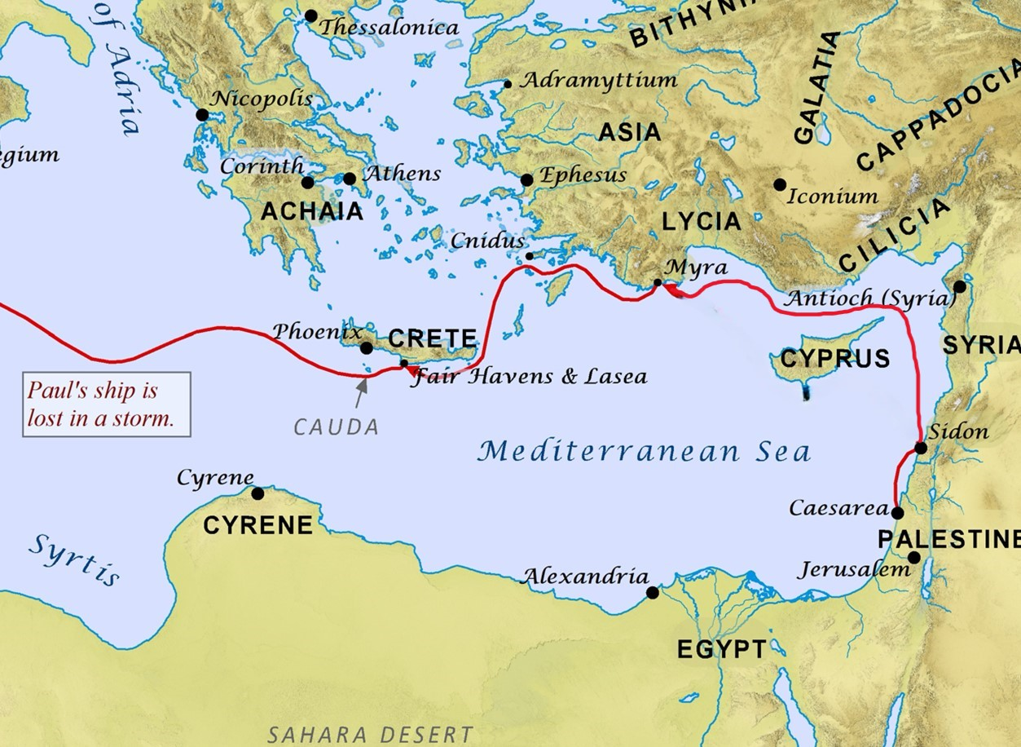
After they left Sidon, the ship headed out over open waters and sailed north toward the island of Cyprus. We are told that this part of the journey was difficult due to the headwinds, but they finally made it to the north side of Cyprus where they were sheltered from the wind between the island and the mainland. Next, they continued there journey west along the southern coast of Asia until they reached their next port at Myra. The difficulty that the ship had during this part of the journey was due to the increasing winds that often occur during the fall and winter months.

Versus 6 thru 8 (Myra to Fair Haven)
The original ship that they had been on was heading northward out of Myra toward its home port in Adramyttium, which was not where the Roman Commander wanted to go. At this point he finds another ship from Alexandria that is sailing for Italy, and he moves the prisoners onto this new ship. Winter is fast approaching, and the seas are getting rougher and more unpredictable with each passing day. The ship leaves Myra and heads west for several days, but the winds are fighting against their westward track, so they decide to head southwest toward the island of Crete.
When they finally made it to the island of Crete, the tall mountains of the island sheltered them from the wind and made it easier to travel until they had to turn west again. As they struggled along the southern coast of Crete, they finally make it to a small port town of Fair Haven near the town of Lasea and stop there for a short time.

Versus 9 thru 12 (A Poor Decision)
Paul knew that it was getting too late in the season to continue the journey, and he tells the Roman commander that if they keep going he thinks they will lose the ship and its cargo. We don’t know if this was merely Paul’s personal opinion with his long sailing history or if this was an inspired warning from the Holy Spirit. I personally think it was both and Paul is trying to prevent a tragedy and make sure that he eventually made it to Rome. Apparently, there was some discussion between the Roman Commander and the ships crew about whether they should stay where they were or try to continue their journey. It seems that the crew did not want to stay in Fair Haven. This port was small and exposed to the elements and the ship’s captain and the crew decide to keep sailing around the coast until they came to the next port in Phoenix.
The port at Phoenix was only about 40 miles away from Fair Haven, and should have only taken them one or two days depending on the winds. The port at Phoenix was shaped like a “C” and had better protection from the elements, and it was a larger town where the crew preferred to spend the winter. So the ships captain and the crew decide to ignore Paul’s warning and head out for Phoenix. After all, in their eyes he was just a prisoner and what did he know about sea travel. They would soon regret their decision to ignore Paul’s good advice.

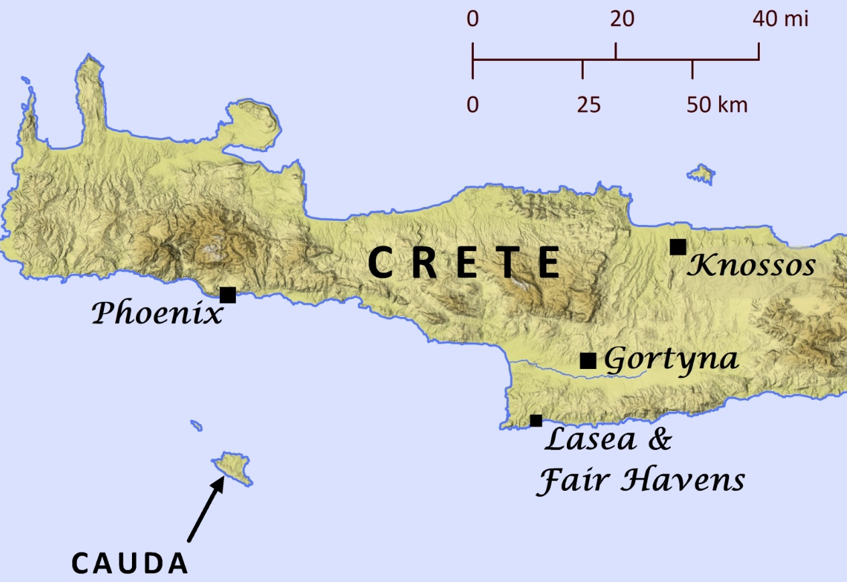

Versus 13 thru 15 (Blown Off Course)
Soon the winds died down and there was only a light breeze from the south, and the sailors thought this was their chance to make it to Phoenix. They pulled up the anchors and started sailing west, but not long after they put out to sea a monster storm started churning up the water. The KJV calls this storm a Euroclydon, but it was probably something that we would refer to as a northeaster or a hurricane. No matter what you call it, this storm was terrible and threatened to blow them out into the open sea where they did not want to be.
The crew desperately tries to turn the ship back towards the coast of Crete, but it is blowing them south and they cannot turn the ship around. Eventually the crew gives up on trying to turn the ship into the storm, and they simply let it run with the wind rather than try to fight against it. Trying to turn a ship into the wind and waves was dangerous, and if the ship turned parallel to a large wave it would sink the ship instantly.

Versus 16 thru 20 (Trying to Save the Ship)
They sailed by the small island of Cauda, and they knew that it was nothing but open ocean once they passed that point. The storm was battering the ship and threatening to tear it to pieces. They hauled in the life rafts that were banging off the side of the ship, and then they took ropes and let them pass partially under the ship and tied them up across the top of the hull to make it stronger.
The winds were driving the ship toward the northern coast of Africa, where there was a large series of shallow sandbars known as the Syrtis. If the ship was driven into these sandbars, it would get stuck and the waves would continually batter the ship until they tore it to pieces. The ship’s captain decided to deploy a device known as a sea anchor to slow down the ship and to keep it pointed into the waves. A sea anchor is basically an underwater parachute that is tied to the bow of the ship and acts as a brake to slow the ship down.
The following morning with the storm still driving the ship southward, the ship’s captain makes a desperate move and he begins to take some of their precious cargo and gear and throw it overboard. Doing this would make the ship lighter and would make it so that it did not run as deep in the water. This might be just enough to keep it from getting stuck on one of the Syrtis sandbars. The storm continues to rage on for many days, and the sailors, soldiers and prisoners are simply at the mercy of the wind and waves.
Read Chapter 27 Versus 21-42 before our next class.

