John Chapter 4 - Part 1 – Test Your Knowledge

- How many people did Jesus baptize?
- 0
- 10
- 12
- We don’t know
- Jesus stayed at Abraham’s well while the disciples went into town to get some food?
- True
- False

- How many husbands had the Samaritan woman been married too?
- 0
- 1
- 5
- 6

- Jesus asked the Samaritan woman for something. What was it?
- Food
- Water
- Clothes
- Shelter

- What type of water did Jesus offer to the Samaritan woman?
- Healing water
- Cleansing water
- Pure water
- Living water

Bonus (20 Points): Which Mountain did the Samaritans worship on?

______________

Grade: _______ (20 Points for each correct answer)

Recap from the Last Class
In chapter 3, Jesus and His disciples traveled through Judea baptizing those who repented, but scripture later clarifies that Jesus Himself did not baptize—only His disciples did. Meanwhile, John the Baptist continued baptizing at Aenon, where a dispute arose between his disciples and certain Jews, probably Pharisees, over purification and the growing popularity of Jesus’ ministry, which made John’s disciples feel threatened. John corrected their perspective, reminding them that all ministry comes from God, that he was not the Messiah, and that his role was to prepare the way for Jesus, rejoicing that Christ must increase while he must decrease. Verses 31-36 affirm Jesus’ divine origin, His unique authority as the One from Heaven, and the unity between the Father and the Son, to whom all things have been entrusted. The passage closes with a sober reminder that eternal life belongs to those who believe in Jesus, while those who reject Him remain under God’s wrath. This should motivate believers to faithfully share the gospel, knowing that even a single conversation may plant a seed leading someone to salvation.
John – Chapter 4 (NLT)

Jesus and the Samaritan Woman
¹ Jesus knew the Pharisees had heard that he was baptizing and making more disciples than John ² (though Jesus himself didn’t baptize them—his disciples did). ³ So he left Judea and returned to Galilee.
⁴ He had to go through Samaria on the way. ⁵ Eventually he came to the Samaritan village of Sychar, near the field that Jacob gave to his son Joseph. ⁶ Jacob’s well was there; and Jesus, tired from the long walk, sat wearily beside the well about noontime. ⁷ Soon a Samaritan woman came to draw water, and Jesus said to her, “Please give me a drink.”⁸ He was alone at the time because his disciples had gone into the village to buy some food.
⁹ The woman was surprised, for Jews refuse to have anything to do with Samaritans. She said to Jesus, “You are a Jew, and I am a Samaritan woman. Why are you asking me for a drink?”
¹⁰ Jesus replied, “If you only knew the gift God has for you and who you are speaking to, you would ask me, and I would give you living water.”
¹¹ “But sir, you don’t have a rope or a bucket,” she said, “and this well is very deep. Where would you get this living water? ¹² And besides, do you think you’re greater than our ancestor Jacob, who gave us this well? How can you offer better water than he and his sons and his animals enjoyed?”
¹³ Jesus replied, “Anyone who drinks this water will soon become thirsty again. ¹⁴ But those who drink the water I give will never be thirsty again. It becomes a fresh, bubbling spring within them, giving them eternal life.”
¹⁵ “Please, sir,” the woman said, “give me this water! Then I’ll never be thirsty again, and I won’t have to come here to get water.”
¹⁶ “Go and get your husband,” Jesus told her.
¹⁷ “I don’t have a husband,” the woman replied.
Jesus said, “You’re right! You don’t have a husband— ¹⁸ for you have had five husbands, and you aren’t even married to the man you’re living with now. You certainly spoke the truth!”
¹⁹ “Sir,” the woman said, “you must be a prophet. ²⁰ So tell me, why is it that you Jews insist that Jerusalem is the only place of worship, while we Samaritans claim it is here at Mount Gerizim, where our ancestors worshiped?”
²¹ Jesus replied, “Believe me, dear woman, the time is coming when it will no longer matter whether you worship the Father on this mountain or in Jerusalem. ²² You Samaritans know very little about the one you worship, while we Jews know all about him, for salvation comes through the Jews. ²³ But the time is coming—indeed it’s here now—when true worshipers will worship the Father in spirit and in truth. The Father is looking for those who will worship him that way. ²⁴ For God is Spirit, so those who worship him must worship in spirit and in truth.”
²⁵ The woman said, “I know the Messiah is coming—the one who is called Christ. When he comes, he will explain everything to us.”
²⁶ Then Jesus told her, “I am the Messiah!”

Verses 1 thru 3 (Who did Jesus baptize?)‬‬‬‬‬
In chapter 3, we were told that some Jews had a debate with the disciples of John the Baptist. These are probably the same Pharisees that are mentioned here in verse 1 and Jesus knew that this had caused an issue between John the Baptist and his disciples. In John 3:22, the disciples were concerned that “Jesus and his disciples” were baptizing more people than they were.
John the Apostle now clarifies in this first verse Jesus was not baptizing anyone, and it was his disciples who baptized people. Although John the Apostle does not tell us why Jesus decided to leave the area of Judea, most scholars think it was because it was not time for Him to have his first big confrontation with them. Others think it was because He knew that He must meet the woman at the well.
Verses 4 thru 6 (Jacob’s Well)‬‬‬‬‬
Jesus and His disciples traveled north from Judea toward Jesus’ home region of Galilee. There were three possible routes to get from Judea to Galilee during that time. An eastern route followed the Jordan river, and a western route that skirted the mountains along the coastal plains of the Mediterranean Sea. Although both routes were longer than going directly north through the area known as Samaria, most Jews would opt for the longer route, just so they did not have to go into the area of the Samaritans.
The Jews and the Samaritans did not like each other, and the Jews considered the Samaritans to be an impure race and would avoid them at all costs. But Jesus said that he “had” or “must” go through Samaria. Although the Bible does not tell us that His disciples questioned this decision, I’m sure they were wondering why he would insist on taking this path. The fact is that Jesus had a plan that the disciples did not know about.
As they traveled through the region, they approached a town called Sychar. It was about noon and Jesus sat down near a well to rest. This wasn’t just any old well, this was Jacob’s well that he had dug about 1800 years before Jesus sat down by it and it was still producing good water. Jesus had sent the rest of his disciples into the city to buy some food, and He remained at the well by Himself. Why would Jesus send the disciples ahead to Sychar without Him?
Verses 7 thru 9 (A Simple Request)‬‬‬‬‬
A woman from the local village came to the well at midday to draw water. Most of the other women would come early in the morning to draw water and avoid coming in the heat of the day. The fact that she came during the middle of the day, probably means that she was an outcast. As she approached the well, Jesus asked her for a drink of water and the woman sarcastically asks Him why he is asking her for a drink.
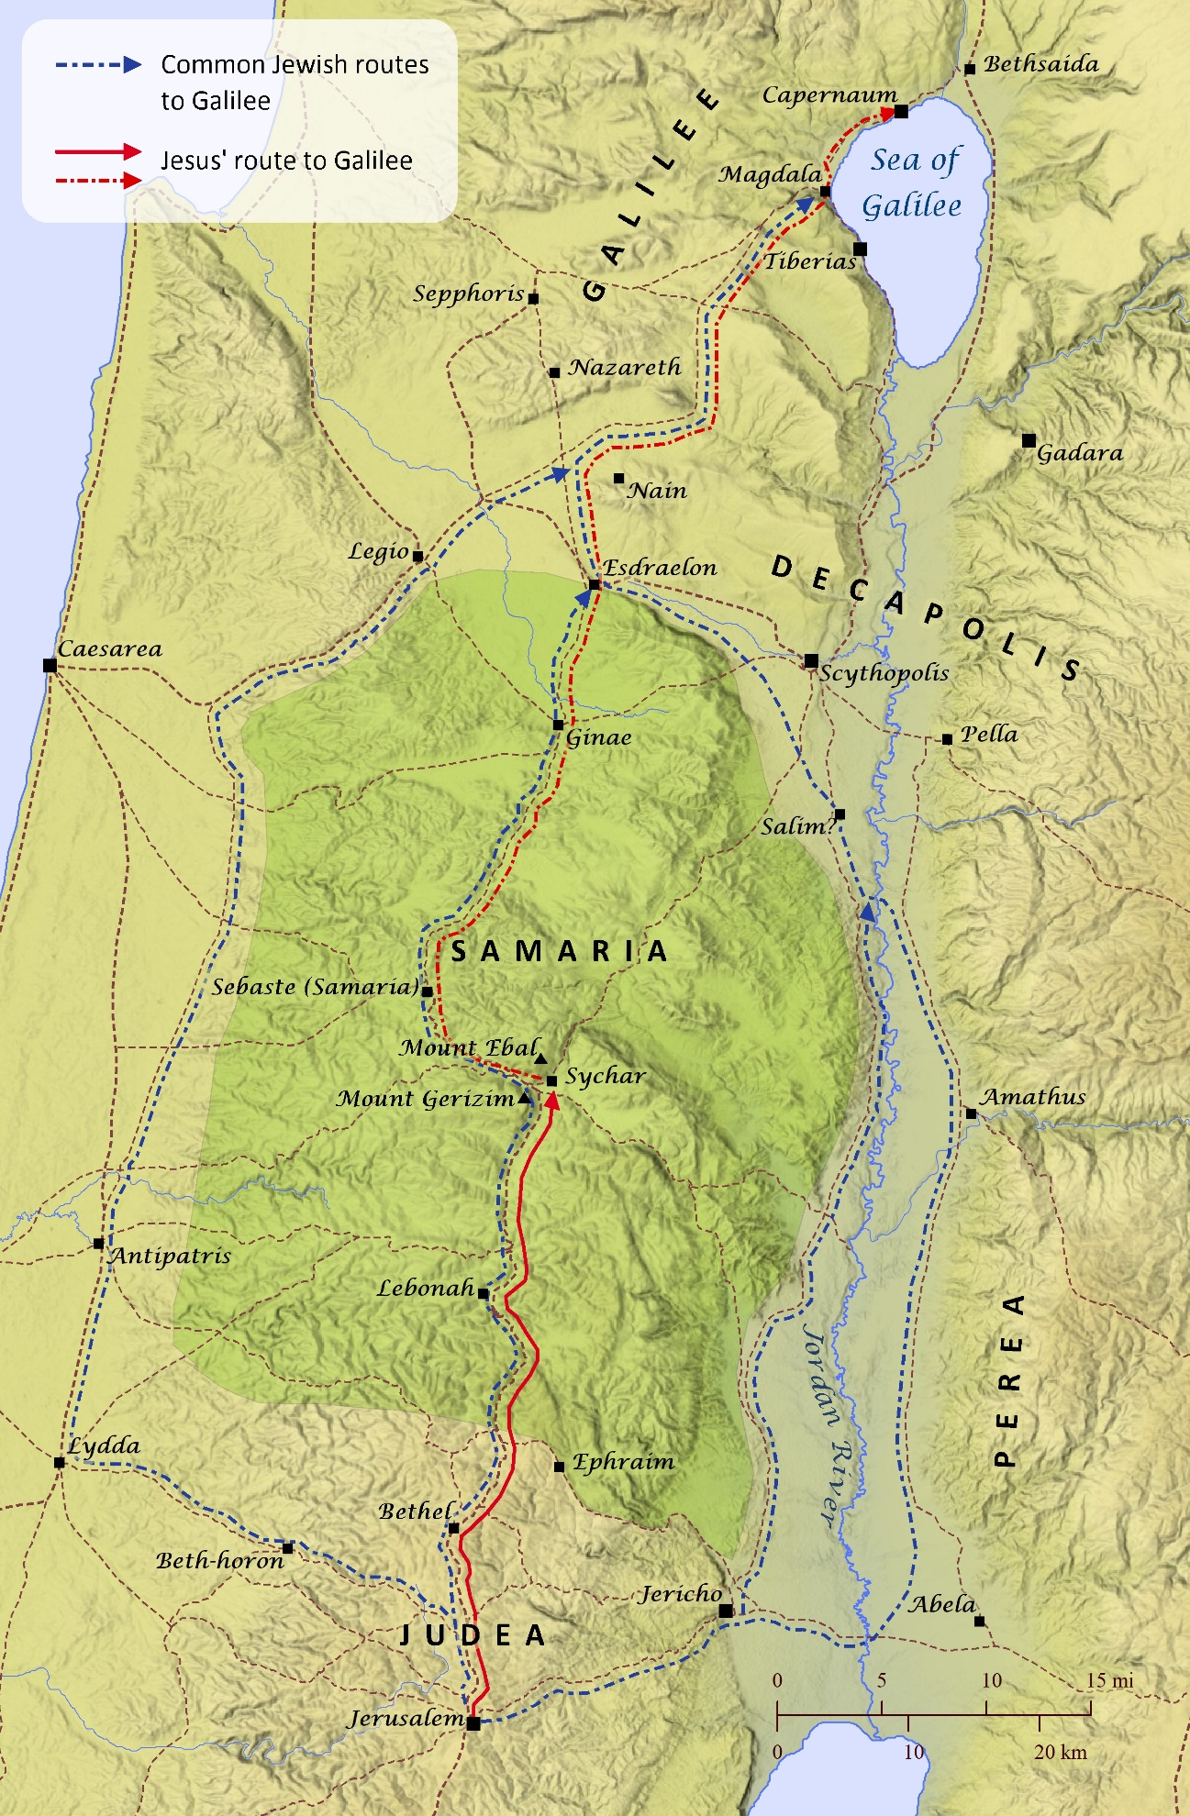
Verses 10 thru 12 (Living Water)‬‬‬‬‬
Jesus now changes the conversation from her giving Him a drink to quench His parched mouth, to Him giving her “living water.” Instead of her showing hospitality to Him and giving Him a drink, now Jesus offers her a gift from God. This same gift of God is available to every single person on this earth, if only they would ask for it.
The woman is still confused, and she is still thinking about physical water. She does not understand that what Jesus is offering her is infinitely more valuable. She questions Jesus and wants to know how He will draw out this water, because he doesn’t have a rope or a bucket to dip out the water. She also questions whether Jesus is greater than their hero Jacob who dug the well. She doesn’t yet know who Jesus is and doesn’t believe anyone can provide better water than their ancestor. She also emphasizes that Jacob is “our” ancestor and he gave “us” this well. Both of these indicate that she is claiming that both Jacob and the well belong to the Samaritans and not the Jews. You could probably feel the social tension building in the air.
Verses 13 thru 15 (Never Thirst Again)‬‬‬‬‬
Jesus is not offended by her attitude toward Him, and instead He offers her something that she cannot resist. Jesus tells her that regular water may temporarily quench your thirst, but the water that He is offering her will give her eternal life and she will never thirst again. This water is spiritual life that purifies the dirtiest soul and lasts forever. Now he has her attention, but she still doesn’t completely understand what Jesus is offering her.
She now replies by saying “please give me this water.” Her attitude is changed and she no longer has a sarcastic attitude. This is the beginning of her acceptance of Christ. Although she doesn’t completely understand what Jesus is saying, she knows that He has something that she wants. She proceeds to tell Him that the reason why she wants what He is offering her, is so she won’t be thirsty anymore and she won’t have to draw water from the well. This would prevent her from having to face her own social issues with the women in the town and she would not have to come during the heat of the day.
Verses 16 thru 18 (Divine Knowledge)‬‬‬‬‬
Jesus now tells the woman to go and get her husband, but He already knows that the woman isn’t married. Why would He ask her this, knowing she wasn’t married?
The woman answers truthfully and says that she isn’t married, but she doesn’t offer to tell Him that she is living with someone. This was part of her shame, and I can just see her attitude changing from excited about this living water to now hanging her head low and hoping that this stranger does not know about her past or present situation. Jesus knows everything about every person, and nothing is hidden from Him. He knows our good thoughts and our bad thoughts. He knows about our good deeds and our bad ones too. He saw you when you witnessed to that person in the grocery store and He smiled. He also saw you walk away from that person at work, who you know He wanted you to witness too and He cried. He knows it all, the good, the bad and the ugly.
Jesus now confronts her about her sinful life and reveals to her that He knows that she is currently living with a man that she is not married too, and He knows that she has been married to five other men. Even in today’s society where divorce is common, being married five times will often draw some weird looks. Although we had not been told this detail so far in this chapter, this was the reason she was likely an outcast and was not accepted by the other women in the town. This shame likely dominated her life, but Jesus was about to remove all that shame.
Verses 19 thru 21 (The Place of Worship)‬‬‬‬‬
The woman now realizes that Jesus is at least a great prophet, and she asks Him a question that must have troubled her for some time. She wants to know if the proper place to worship is on Mount Gerizim where the Samaritans worshiped, or at Jerusalem where the Jews worship. The Samaritans claimed that Mount Gerizim was the holy place where they should worship God, and they believed that this was the same place where Abram had almost sacrificed Issac. This was also the place where Moses commanded Joshua to build an alter and pronounced blessings on Israel (Duet.11, Joshua 8). They had built their own temple there on Mount Gerizim around 500BC-400BC, but it was later destroyed by the Maccabees in 110BC. Although the temple was destroyed, the Samaritans still worshiped there and a small number of them still do today.
Jesus could have gotten into a theological debate about which temple was the greatest, but instead He tells her that the time is coming when it will not matter where you choose to worship. This reply probably surprised the woman who was expecting Jesus to defend the temple in Jerusalem. We need to make sure that we also do not get trapped in this debate.
Have you ever heard of this type of debate? Is the Whitwell Church of God better than the Southern Baptist or the Methodist church? What about the non-denominational church, is it better than it? We should spend less time worrying about “where” someone goes to church, and more time just encouraging them to “go” to church. There are some churches with some questionable doctrines, but we should spend less time worrying about that and more time winning souls. Just let God lead them to the “right” church.

Verses 22 thru 26 (I AM the Messiah)‬‬‬‬‬
Jesus goes on to explain to the woman that the Samaritans know very little about who it is that they worship. He also tells them that the time has finally arrived when they will worship God in the spirit. The woman says that she knows about the Messiah and apparently, they had been told that when the Messiah came, that He would explain all of these things to them.
Jesus’ reply shocked the woman when he said “I AM the Messiah.” He was the Messiah and He was the Great I AM. When God talked to Moses in the Old Testament, He often referred to Himself as the “I AM” and the woman would have recognized Jesus’ use of these. She now realizes that she is standing in the presence of the Messiah, and her whole world has just changed.
What did you learn from this class? _______________________________________ ________________________________________________________________________________________________________________________________________________________________________________________________________________________________________________________________________________________

