Acts Chapter 27 Part 2 – Test Your Knowledge

- What place did Paul say that they should not have left?
- Fair Haven
- Phoenix
- Myra
- Crete

- Who was visited by an angel and told about the shipwreck?
- Luke
- Julius
- Paul
- Aristarchus

- How long had they been in the storm when they sensed that they were near land?
- 3 days
- 30 days
- 7 days
- 14 days

- How deep was it the first time they measured the water?
A. 120 feet / 20 fathoms
B. 90 feet / 15 fathoms
C. 60 feet / 10 fathoms
D. 30 feet / 5 fathoms

- How many people survived the shipwreck?
- 73 / threescore and thirteen
- 221 / two hundred twoscore and one
- 276 / two hundred threescore and sixteen
- 90 / fourscore and 10

Bonus (20 Points): What was the name of the island where they were shipwrecked? __________________________________________________________________

Grade: _____ (20 Points for each correct answer)

In the first 20 versus of chapter 27, Paul begins his final journey to Rome as a prisoner aboard a ship from Adramyttium. Paul is allowed to go ashore in Sidon to meet with some believers and then the ship struggles along the southern coast of Asia until it reaches Myra. There they change ships and continue to their journey toward Italy, but the seas get worse each day. They finally make it to Crete and land at the port in Fair Haven, where they are faced with making the decision of where to spend the winter. Paul warns them to stay in Fair Haven, but the ship’s crew decides to continue on to a port at Phoenix. When they leave Fair Haven they encounter a severe storm that blows them out to sea, and they are unable to turn the ship in the direction they wanted to go. They deploy a sea anchor to slow them down and throw over some of the cargo and ships gear to lighten the ship. Verse 21 picks up with them still in the midst of the storm and things are still getting worse.

Acts 27 Versus 21-44 (NLT)

The Storm at Sea
²¹ No one had eaten for a long time. Finally, Paul called the crew together and said, “Men, you should have listened to me in the first place and not left Crete. You would have avoided all this damage and loss. ²² But take courage! None of you will lose your lives, even though the ship will go down. ²³ For last night an angel of the God to whom I belong and whom I serve stood beside me, ²⁴ and he said, ‘Don’t be afraid, Paul, for you will surely stand trial before Caesar! What’s more, God in his goodness has granted safety to everyone sailing with you.’²⁵ So take courage! For I believe God. It will be just as he said. ²⁶ But we will be shipwrecked on an island.”

The Shipwreck
²⁷ About midnight on the fourteenth night of the storm, as we were being driven across the Sea of Adria, the sailors sensed land was near. ²⁸ They dropped a weighted line and found that the water was 120 feet deep. But a little later they measured again and found it was only 90 feet deep. ²⁹ At this rate they were afraid we would soon be driven against the rocks along the shore, so they threw out four anchors from the back of the ship and prayed for daylight.
³⁰ Then the sailors tried to abandon the ship; they lowered the lifeboat as though they were going to put out anchors from the front of the ship. ³¹ But Paul said to the commanding officer and the soldiers, “You will all die unless the sailors stay aboard.” ³² So the soldiers cut the ropes to the lifeboat and let it drift away.
³³ Just as day was dawning, Paul urged everyone to eat. “You have been so worried that you haven’t touched food for two weeks,” he said. ³⁴ “Please eat something now for your own good. For not a hair of your heads will perish.” ³⁵ Then he took some bread, gave thanks to God before them all, and broke off a piece and ate it. ³⁶ Then everyone was encouraged and began to eat— ³⁷ all 276 of us who were on board. ³⁸ After eating, the crew lightened the ship further by throwing the cargo of wheat overboard.
³⁹ When morning dawned, they didn’t recognize the coastline, but they saw a bay with a beach and wondered if they could get to shore by running the ship aground. ⁴⁰ So they cut off the anchors and left them in the sea. Then they lowered the rudders, raised the foresail, and headed toward shore. ⁴¹ But they hit a shoal and ran the ship aground too soon. The bow of the ship stuck fast, while the stern was repeatedly smashed by the force of the waves and began to break apart.
⁴² The soldiers wanted to kill the prisoners to make sure they didn’t swim ashore and escape. ⁴³ But the commanding officer wanted to spare Paul, so he didn’t let them carry out their plan. Then he ordered all who could swim to jump overboard first and make for land. ⁴⁴ The others held on to planks or debris from the broken ship. So everyone escaped safely to shore.

Verse 21 (Should have listened to Paul)
It has now been about one week and the storm that blew them away from Crete is still raging. The crew had given up hope and they were just waiting until the ship would be capsized by a wave or crash into a reef or sandbar. The storm was so violent that all of their effort had been put into saving the ship and no one had eaten for a long time. All hope was lost for everyone, except Paul. Paul knew that he would make it to Rome, but what about the rest of the crew? Paul had been a prisoner on the ship up until now, but now he changes from prisoner to preacher. He reminds the men that he had given them a warning before they left Fair Haven not to continue the journey, but no one had listened to Paul, at least not until now.

Verses 22 thru 26 (A message from an Angel)
Paul gathers the crew around him in the midst of the storm and tells them that he has had a visit from an angel. This angel had told Paul that the ship would be lost to the violent storm, but that none of the crew would perish. Paul’s mission to stand before Ceasar would require that every man aboard the ship do his part to reach their final destination. God has placed every soul aboard the ship in Paul’s care, and God sent an angel to give them this message. Paul’s trust in God must have been an inspiring sight to these weary souls.
Paul was in the same storm that they were in, but he had a different attitude. Paul was not spared from the storm, but God sent an angel to guide him through it. He was probably seasick like everyone else, but his outlook was not the same as theirs. Sometimes we wonder why we are going through a trial and why God did not spare us. Sometimes we must go through a storm so others can see the difference in a Godly person who has hope in Jesus, and an ungodly person who has no hope at all. The next time you are in a trial, look around and see who is watching you and then see how brightly your light can shine in the midst of the darkness.

Verses 27 thru 29 (Praying for Daylight)
Two horrific weeks had passed by and the storm was still battering the boat and the ship was lost at sea. They had no idea where they were, but suddenly they sensed that they were near land. At this point it was dark and they could not see anything, so how did they know that they were near land? Have you ever heard the sound of waves crashing near the shore? When the waves start moving into shallow water, the wave speed becomes slower on the ocean floor and causes the top of the wave to move faster. Since the top of the wave moves faster, it moves higher and farther out until the top folds over and crashes back into the ocean.
These sailors knew what the sound of crashing waves meant, so they begin to take sounding or depth measurements. They would tie a lead weight to the end of a long line. The line would be marked off in 6 feet intervals called fathoms. They would stand on the outside of the ship and cast the lead towards the front of the ship and then let is sink until it hit the bottom. Then they would just count the number of fathom marks on the line to tell how deep the water was. Knowing that they were near land due to the sound of crashing waves, they started taking soundings and at first they find that the water was 120 feet deep. They wait a little while longer and then take another sounding and now find that the water is only 90 feet deep. At this rate they will soon run aground on a reef or a sandbar, so they throw out four anchors from the back of the ship and pray for daylight.

Verses 30 thru 32 (Do not abandon the Ship)
At some point during the night, a few of the sailors decide that they are going to try to escape in the lifeboats rather than crash on the reef. They make their way to the front of the ship and act like they are going to let down another anchor, but instead they lower the lifeboats down into the sea. Paul learns of their plans, and he tells the Roman officer that everyone must stay on the ship or everyone will perish. Paul is now the commander of this ship, and the Roman soldiers obey his orders. They rush toward the front of the ship and quickly cut the ropes holding the lifeboats and let them drift away in the sea.

Verses 33 thru 38 (Eat Something)
As daylight began to break on the fourteenth day of their ordeal, Paul gathers the soldiers and sailors once more and encourages them to eat something. Everyone went without food, but Paul knows that they will need energy to be able to swim to shore. Paul reassures them that not one hair on their head will be damaged and he blesses some bread and shares a small meal. Breaking bread or sharing a meal with someone during hard times is a good way to comfort someone, especially when they are going through a trial.
We are told in verse 37 that there were 276 souls aboard this ship, and that everyone shared this meal with Paul. After they had eaten, they go about the work of lightening the ship as much as possible. They had already thrown some of the cargo and gear over on the third day of the storm, but now they begin to toss over the precious cargo of wheat which was the most valuable thing on the ship.

Verses 39 thru 41 (Shipwreck)
The storm may have let up some up at this point and they are now able to see land. They did not recognize this island and at this point they could have been anywhere from Africa to Italy. They see a small beach and they think that they may be able to run the ship aground close to the shore and then be able to walk in the water the rest of the way to dry land. They cut loose the anchors and hoist the main sail to get up some speed. They lower two giant rudders into the water that are used to steer the ship and they point it toward the beach
As they head toward the beach, they know that they run the risk of hitting a reef or a sandbar, but they go full speed ahead anyway. The ship suddenly comes to an abrupt stop, and they find themselves stuck on a reef. The front of the ship had wedged itself firmly into the ground or some rocks, but the back of the ship is still being battered by the waves. With the front of the ship not moving but the back of the ship still being tossed around, the ship begins to break apart!

Verses 42 thru 44 (Abandon Ship)
As we had discussed in earlier chapters, the Roman soldiers who guarded the prisoners were afraid that if any of the prisoners escaped that they would be put to death in their place. The soldiers decide that it would be better to just kill all the prisoners, rather than letting them escape. But the Roman commander respected Paul enough at this point that he wanted to spare his life, and in return spare the life of all of the other prisoners.
The order was given that anyone who could not swim should jump overboard first, and use planks that had broken off of the ship as a floatation device to paddle to shore. After the non-swimmers had gone overboard, everyone else jumped into the water and swam for the shore. 276 people jumped overboard, and all 276 people made it safely to the shore. Paul’s prophetic message had now come true down to the smallest detail. The ship was lost, everyone survived, and they landed on an island named Malta. There is a bay on the north side of Malta today that is named St. Paul’s Bay, and it is rumored to be the spot where they swam ashore.
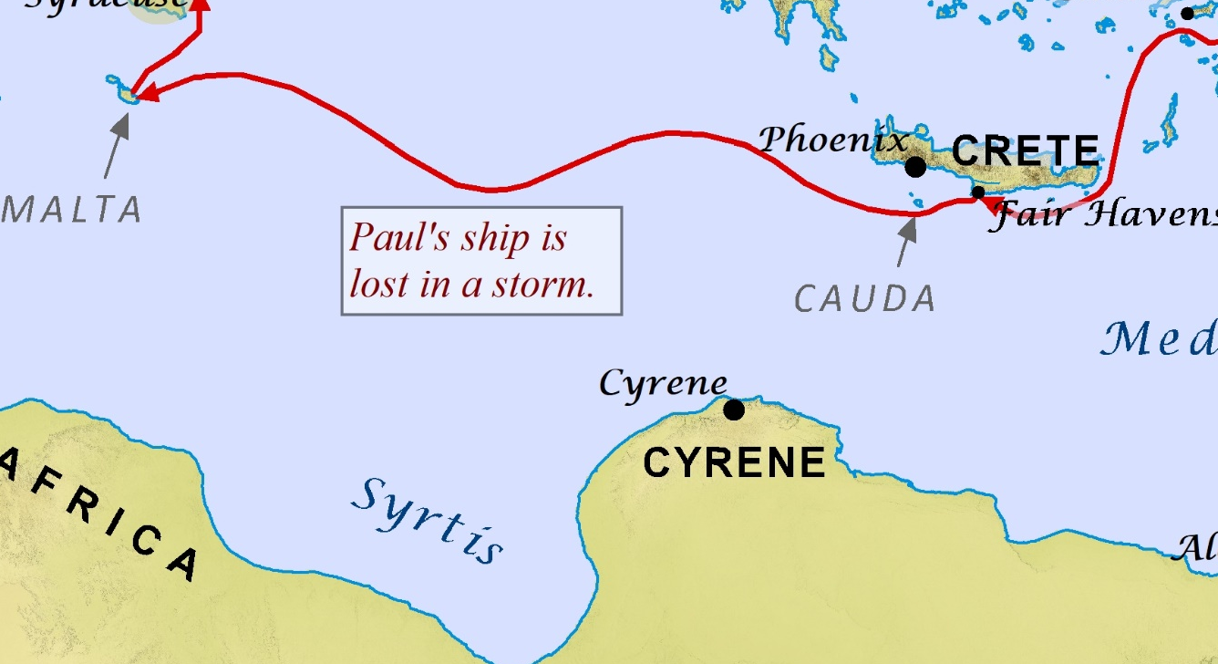
Read Chapter 28 before our next class.

