Acts Chapter 9 Part 1– Test Your Knowledge

- What city was Saul traveling to in the beginning of this chapter?
- Jerusalem
- Caesarea
- Samaria
- Damascus

- Who did Saul meet on his way on the road?
- Simon
- Jesus
- Peter
- Barnabas

- Whose house was Saul staying at on Straight Street?
- Benjamin
- Peter
- Judas
- Ananias

- What was the name of the person who prayed for Saul to receive his sight?
- Ananias
- Peter
- Dorcus
- Aeneas

- How many days was Saul blind?
- 1
- 3
- 5
- We don’t know

Bonus (20 Points): How long did Saul stay in Damascus? ___________

Grade:_____ (20 Points for each correct answer)

The Acts of the Apostles – Chapter 9 Part 1

In chapter 8, we learned about Saul’s relentless campaign to hunt down Christians and we learned about Philip’s amazing ministry. Chapter 9 continues the story of persecution and growth in the church, but with a new apostle.

Saul’s Conversion
¹Meanwhile, Saul was uttering threats with every breath and was eager to kill the Lord’s followers. So he went to the high priest. ² He requested letters addressed to the synagogues in Damascus, asking for their cooperation in the arrest of any followers of the Way he found there. He wanted to bring them—both men and women—back to Jerusalem in chains.
³ As he was approaching Damascus on this mission, a light from heaven suddenly shone down around him. ⁴ He fell to the ground and heard a voice saying to him, “Saul! Saul! Why are you persecuting me?”
⁵ “Who are you, lord?” Saul asked.
And the voice replied, “I am Jesus, the one you are persecuting! ⁶ Now get up and go into the city, and you will be told what you must do.”
⁷ The men with Saul stood speechless, for they heard the sound of someone’s voice but saw no one! ⁸ Saul picked himself up off the ground, but when he opened his eyes he was blind. So his companions led him by the hand to Damascus. ⁹ He remained there blind for three days and did not eat or drink.
¹⁰ Now there was a believer in Damascus named Ananias. The Lord spoke to him in a vision, calling, “Ananias!”
“Yes, Lord!” he replied.
¹¹ The Lord said, “Go over to Straight Street, to the house of Judas. When you get there, ask for a man from Tarsus named Saul. He is praying to me right now. ¹² I have shown him a vision of a man named Ananias coming in and laying hands on him so he can see again.”
¹³ “But Lord,” exclaimed Ananias, “I’ve heard many people talk about the terrible things this man has done to the believers in Jerusalem!¹⁴ And he is authorized by the leading priests to arrest everyone who calls upon your name.”
¹⁵ But the Lord said, “Go, for Saul is my chosen instrument to take my message to the Gentiles and to kings, as well as to the people of Israel. ¹⁶ And I will show him how much he must suffer for my name’s sake.”
¹⁷ So Ananias went and found Saul. He laid his hands on him and said, “Brother Saul, the Lord Jesus, who appeared to you on the road, has sent me so that you might regain your sight and be filled with the Holy Spirit.” ¹⁸ Instantly something like scales fell from Saul’s eyes, and he regained his sight. Then he got up and was baptized. ¹⁹ Afterward he ate some food and regained his strength.

Saul in Damascus and Jerusalem
Saul stayed with the believers in Damascus for a few days. ²⁰ And immediately he began preaching about Jesus in the synagogues, saying, “He is indeed the Son of God!”
²¹ All who heard him were amazed. “Isn’t this the same man who caused such devastation among Jesus’ followers in Jerusalem?” they asked. “And didn’t he come here to arrest them and take them in chains to the leading priests?”
²² Saul’s preaching became more and more powerful, and the Jews in Damascus couldn’t refute his proofs that Jesus was indeed the Messiah. ²³ After a while some of the Jews plotted together to kill him.²⁴ They were watching for him day and night at the city gate so they could murder him, but Saul was told about their plot. ²⁵ So during the night, some of the other believers lowered him in a large basket through an opening in the city wall.
²⁶ When Saul arrived in Jerusalem, he tried to meet with the believers, but they were all afraid of him. They did not believe he had truly become a believer! ²⁷ Then Barnabas brought him to the apostles and told them how Saul had seen the Lord on the way to Damascus and how the Lord had spoken to Saul. He also told them that Saul had preached boldly in the name of Jesus in Damascus.
²⁸ So Saul stayed with the apostles and went all around Jerusalem with them, preaching boldly in the name of the Lord. ²⁹ He debated with some Greek-speaking Jews, but they tried to murder him.³⁰ When the believers heard about this, they took him down to Caesarea and sent him away to Tarsus, his hometown.
³¹ The church then had peace throughout Judea, Galilee, and Samaria, and it became stronger as the believers lived in the fear of the Lord. And with the encouragement of the Holy Spirit, it also grew in numbers.

Peter Heals Aeneas and Raises Dorcas
³² Meanwhile, Peter traveled from place to place, and he came down to visit the believers in the town of Lydda. ³³ There he met a man named Aeneas, who had been paralyzed and bedridden for eight years. ³⁴ Peter said to him, “Aeneas, Jesus Christ heals you! Get up, and roll up your sleeping mat!” And he was healed instantly. ³⁵ Then the whole population of Lydda and Sharon saw Aeneas walking around, and they turned to the Lord.
³⁶ There was a believer in Joppa named Tabitha (which in Greek is Dorcas). She was always doing kind things for others and helping the poor. ³⁷ About this time she became ill and died. Her body was washed for burial and laid in an upstairs room. ³⁸ But the believers had heard that Peter was nearby at Lydda, so they sent two men to beg him, “Please come as soon as possible!”
³⁹ So Peter returned with them; and as soon as he arrived, they took him to the upstairs room. The room was filled with widows who were weeping and showing him the coats and other clothes Dorcas had made for them. ⁴⁰ But Peter asked them all to leave the room; then he knelt and prayed. Turning to the body he said, “Get up, Tabitha.” And she opened her eyes! When she saw Peter, she sat up! ⁴¹ He gave her his hand and helped her up. Then he called in the widows and all the believers, and he presented her to them alive.
⁴² The news spread through the whole town, and many believed in the Lord. ⁴³ And Peter stayed a long time in Joppa, living with Simon, a tanner of hides.
Verses 1 and 2 (The Wrath of Saul)‬‬‬‬‬
Some time has passed since Stephen’s death and Saul hears about the growing church in Damascus. Saul has been devastating the believers in Jerusalem and now he is determined to go to Damascus and continue his campaign in that region. Damascus was about 140 miles north of Jerusalem and the church had grown there in a very short amount of time. It had apparently grown so much, that the word of its success had made its way back to Jerusalem and infuriated Saul. Saul went to the Jewish leaders and asks them for permission and letters to go after the Christians in Damascus. It isn’t clear if the synagogue in Jerusalem had authority over the synagogue in Damascus or if the letters were just an official approval of Saul’s work. The letters gave Saul permission to capture any followers of “The Way” and bring them back to Jerusalem in chains to stand trial. This is the first time the “The Way” is used to describe the Christians in the Bible and it probably came from Jesus saying, “I am the way and the truth and the life. No one comes to the Father except through me.” (John 14:6).
Verses 3 thru 6 (Saul’s Damascus Road Experience)‬‬‬‬‬
With his official letters from the synagogue, Saul heads for Damascus with a zealous mission to destroy the followers of Christ. Saul was undoubtedly very familiar with who Jesus was, and he may have heard Him preach before he was crucified. To be successful and destroy an enemy, you must first study your enemy and try to understand who they are. In this same thought, Saul was probably very familiar with who Jesus was and that He had claimed to be the Messiah. Saul also knew about the resurrection story, but had never met the resurrected Christ.
As Saul is on the road to Damascus, a blinding light appears to him, and he falls to the ground. Paul later repeats this same story two more times in Acts 22:6-10 and Acts 26:12-1 and each time we are given a few more details. Saul hears a voice call out to him from the light and He says, “Saul! Saul! Why are you persecuting Me.” Saul’s reply is curious that he calls Him “Lord” and then asks who He is. The Greek word used here is κύριε which means “Sir” or “Lord” and it is used eleven times in Acts. Ten of those times it used as “Lord Jesus”, but in this instance we are unsure if Saul recognized Jesus or if he was just addressing this heavenly messenger as “Sir”. Either way, the answer is plainly given when the voice says, “I am Jesus” leaving no doubt that Saul met his savior that day. In pure obedience Saul asked him what he should do, and Jesus tells Saul to go into the city and await further instruction.
Verses 7 thru 9 (Three Days in the Dark)‬‬‬‬‬
Saul’s companions who had been with him saw the light and heard the voice but could not understand the messenger. When Saul gets up, he finds out that he is blind but the rest of his companions can still see. Jonah spent three days in the belly of the whale, Jesus spent three days in the tomb and Saul spent three days in the dark. During these three days, Saul fasted and one must think that he spent most of his time in prayer. Everything that he had believed about Jesus was a lie and now he was living evidence of the truth. Saul probably repented many times in these three days as he sat there in utter darkness. He had been reflecting on the cruelty he had inflicted on the believers and now, he is one of them. This is often why Saul referred to himself as the chief of sinners.
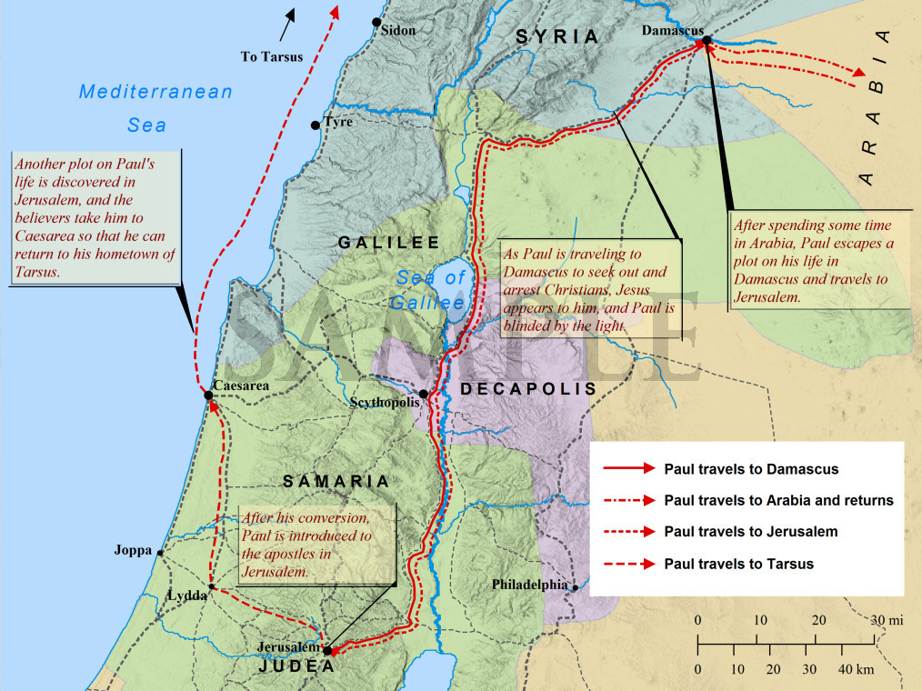
Verses 10 thru 16 (Ananias and Saul’s Vision)‬‬‬‬‬
Ananias was a disciple living in Damascus and the Lord called to him by name in a vision and Ananias simply replied, “Here I am, Lord.” Ananias was not one of the apostles. He was not an elder, a deacon or a pastor. He was just a believer who was listening for God to speak to him, and he was willing to serve when he was called upon. Are you listening for the still small voice of God? Are you willing to answer the call? Are you prepared for the mission?
Ananias was well aware of who Saul was and and he also knows that Saul has letters from the high priest to arrest the Christians in Damascus. Ananias does what any of us would have done and he tells God how ruthless this man has been to the Christians. Doesn’t it seem silly that he would try to tell God who Saul is? But remember that Ananias is just human, and he doesn’t know the future like God does. God reassures him that he has a plan for Saul and that he will be a great witness to the Gentiles and that he will preach the gospel to kings and to the Jews. Ananias may have been a little hesitant at first, but he obeys and finds his way to the house where Saul is staying.
The traveling companions of Saul had taken him to the house of a man named Judas who was living on Straight Street in Damascus. While Saul was praying and fasting, he had seen a vision of Ananias laying his hands on him and praying for Saul’s sight to return.
Verses 17 thru 19 (Saul is Filled with the Holy Ghost)‬‬‬‬‬
Ananias enters Judas’ house and finds Saul. He addresses him as “Brother Saul”, meaning that Ananias had already accepted him as a believer in Christ. Ananias lays his hands on him and prays that he would receive his sight. We are told that something like scales fell off of Saul’s eyes and he is cured of his physical and spiritual blindness. Saul is instantly filled with the Holy Ghost and immediately asks to be baptized.
This should be a great example and a witnessing tool for us to use when people think that they have done really bad stuff and aren’t worthy of God’s grace. Anytime you hear someone say that, you should tell them Saul’s story and let them know that salvation is for everyone. Drugs, infidelity, rebellion and even murder are all just one prayer away from being forgiven. All they have to do is believe in the Lord Jesus Christ and they shall be saved (Acts 16:31, Romans 10:13, John 3:16)!
Verses 20 thru 22 (Saul Preaches the Gospel)‬‬‬‬‬
God has instantly changed this great persecutor of the Christians into the great gospel preacher. Saul immediately goes into the Synagogue and starts to preach about Jesus. Not only is he preaching about Jesus, but when the other Jews try to refute the message that he was preaching, they are unable to beat him. Remember that Saul was a Pharisee who was trained by Gamaliel, the great teacher of Jewish law. Saul is a very smart man and knows the Jewish law as good or better than any of them and now he is filled with the Holy Spirit and has met Jesus on the road to Damascus. Not only could they not refute Saul’s message, but Saul was getting better at preaching everyday. The Old Testament was suddenly coming alive to Saul, and he was seeing how Jesus had fulfilled all of the prophecies and he was sharing it with anyone who would listen.
Verses 23 thru 25 (Kill the Messenger)‬‬‬‬‬
Saul stayed in Damascus for three years (Galatians 1:18) and became the greatest evangelist of all times. The Jews in Damascus saw the power that Saul had, and they are now determined to kill him to stop the spread of the gospel. Saul has now gone from the person who was hunter to the hunted. The Jews had setup outside the city gates and were waiting to ambush and kill Saul as he is leaving the city. But Saul and the other believers hear about the assassination plan and lower Saul in a basket out through a window of the city wall. This was the first attempt to kill Saul, but it would not be the last.

Read Chapter 9 versus 26-42 before our next class.

