Acts Chapter 9 Part 2– Test Your Knowledge

- Who brought Saul to the Apostles and told them about what he did in Damascus?
- Peter
- Simon
- Titus
- Barnabus

- How long was Aeneas bedridden?
- 8 years
- 20 years
- 32 years
- All of his life

- What was the name of the town where Tabitha (Dorcus) from?
- Lydda
- Joppa
- Caesarea
- Tarsus

- Who did Peter stay with while he was living in Joppa?
- Barnabus
- Simon
- Dorcus
- Aeneas

- What was Simon’s occupation?
- Silversmith
- Tent maker
- Tanner
- Priest

Bonus (20 Points): Where did Peter go after he left Joppa? ___________

Grade:_____ (20 Points for each correct answer)

The Acts of the Apostles – Chapter 9 Part 2

In the first part of chapter 9, we read about Saul’s amazing salvation story and how he went from being the person who was hunting the Christians to the person who is now being hunted as a Christian. Saul’s trials continue in the second half of this chapter along with more growth in the church.

Saul Meets the Apostles
²⁶ When Saul arrived in Jerusalem, he tried to meet with the believers, but they were all afraid of him. They did not believe he had truly become a believer! ²⁷ Then Barnabas brought him to the apostles and told them how Saul had seen the Lord on the way to Damascus and how the Lord had spoken to Saul. He also told them that Saul had preached boldly in the name of Jesus in Damascus.
²⁸ So Saul stayed with the apostles and went all around Jerusalem with them, preaching boldly in the name of the Lord. ²⁹ He debated with some Greek-speaking Jews, but they tried to murder him.³⁰ When the believers heard about this, they took him down to Caesarea and sent him away to Tarsus, his hometown.
³¹ The church then had peace throughout Judea, Galilee, and Samaria, and it became stronger as the believers lived in the fear of the Lord. And with the encouragement of the Holy Spirit, it also grew in numbers.

Peter Heals Aeneas and Raises Dorcas
³² Meanwhile, Peter traveled from place to place, and he came down to visit the believers in the town of Lydda. ³³ There he met a man named Aeneas, who had been paralyzed and bedridden for eight years. ³⁴ Peter said to him, “Aeneas, Jesus Christ heals you! Get up, and roll up your sleeping mat!” And he was healed instantly. ³⁵ Then the whole population of Lydda and Sharon saw Aeneas walking around, and they turned to the Lord.
³⁶ There was a believer in Joppa named Tabitha (which in Greek is Dorcas). She was always doing kind things for others and helping the poor. ³⁷ About this time she became ill and died. Her body was washed for burial and laid in an upstairs room. ³⁸ But the believers had heard that Peter was nearby at Lydda, so they sent two men to beg him, “Please come as soon as possible!”
³⁹ So Peter returned with them; and as soon as he arrived, they took him to the upstairs room. The room was filled with widows who were weeping and showing him the coats and other clothes Dorcas had made for them. ⁴⁰ But Peter asked them all to leave the room; then he knelt and prayed. Turning to the body he said, “Get up, Tabitha.” And she opened her eyes! When she saw Peter, she sat up! ⁴¹ He gave her his hand and helped her up. Then he called in the widows and all the believers, and he presented her to them alive.
⁴² The news spread through the whole town, and many believed in the Lord. ⁴³ And Peter stayed a long time in Joppa, living with Simon, a tanner of hides.
Verses 26 and 27 (Saul Goes to Jerusalem)‬‬‬‬‬
Saul had been preaching in Damascus and the surrounding area for three years and the Jews in the town had tried to kill him. Paul escapes through a hole in the city wall and has now traveled to Jerusalem. When he reached Jerusalem, he tried to meet with the believers, but they feared him due to his past. Even though he had been preaching and spreading the gospel for three years, the Apostles and the other disciples still did not trust him. Have you ever known someone who you thought would never get saved and then hear about their miraculous transformation? Did you believe it, or did you doubt that they had “really” been saved?
Barnabus steps forward and reassures the other believers that Saul is a true Apostles and that he had preached mightily while in Damascus. Barnabus may have been in Damascus and heard Saul preach or he may have heard others repeating similar stories. Barnabus’ acknowledgement of Saul is enough to convince the Apostles and they finally accept him into the church.
Verses 28 thru 30 (The Second Attempt to Kill Saul)‬‬‬‬‬
Saul begins to preach boldly and even begins to debate with the same Hellenistic Jews that Stephen had debated with. The Hellenistic Jews were unable to match the knowledge of Saul and decided that if they could not beat him, then they would kill him just like Stephen. The other believers hear about the plot to kill Saul, so they quickly get him out of the city and Saul goes back to his hometown of Tarsus. Saul’s ministry undoubtedly continued in Tarsus, but for a period of about 10 years we don’t hear anything else about Saul and this is known as the quiet period. This will be the last we hear about Saul until we get to chapter 13.
Verse 31 (A Growing Church)‬‬‬‬‬
After Saul leaves, we are told that the church in Judea, Galilee and Samaria enjoy a time of peace and growth. There was still persecution in the church during this time, but we don’t hear anymore about people being thrown in jail or being martyred. 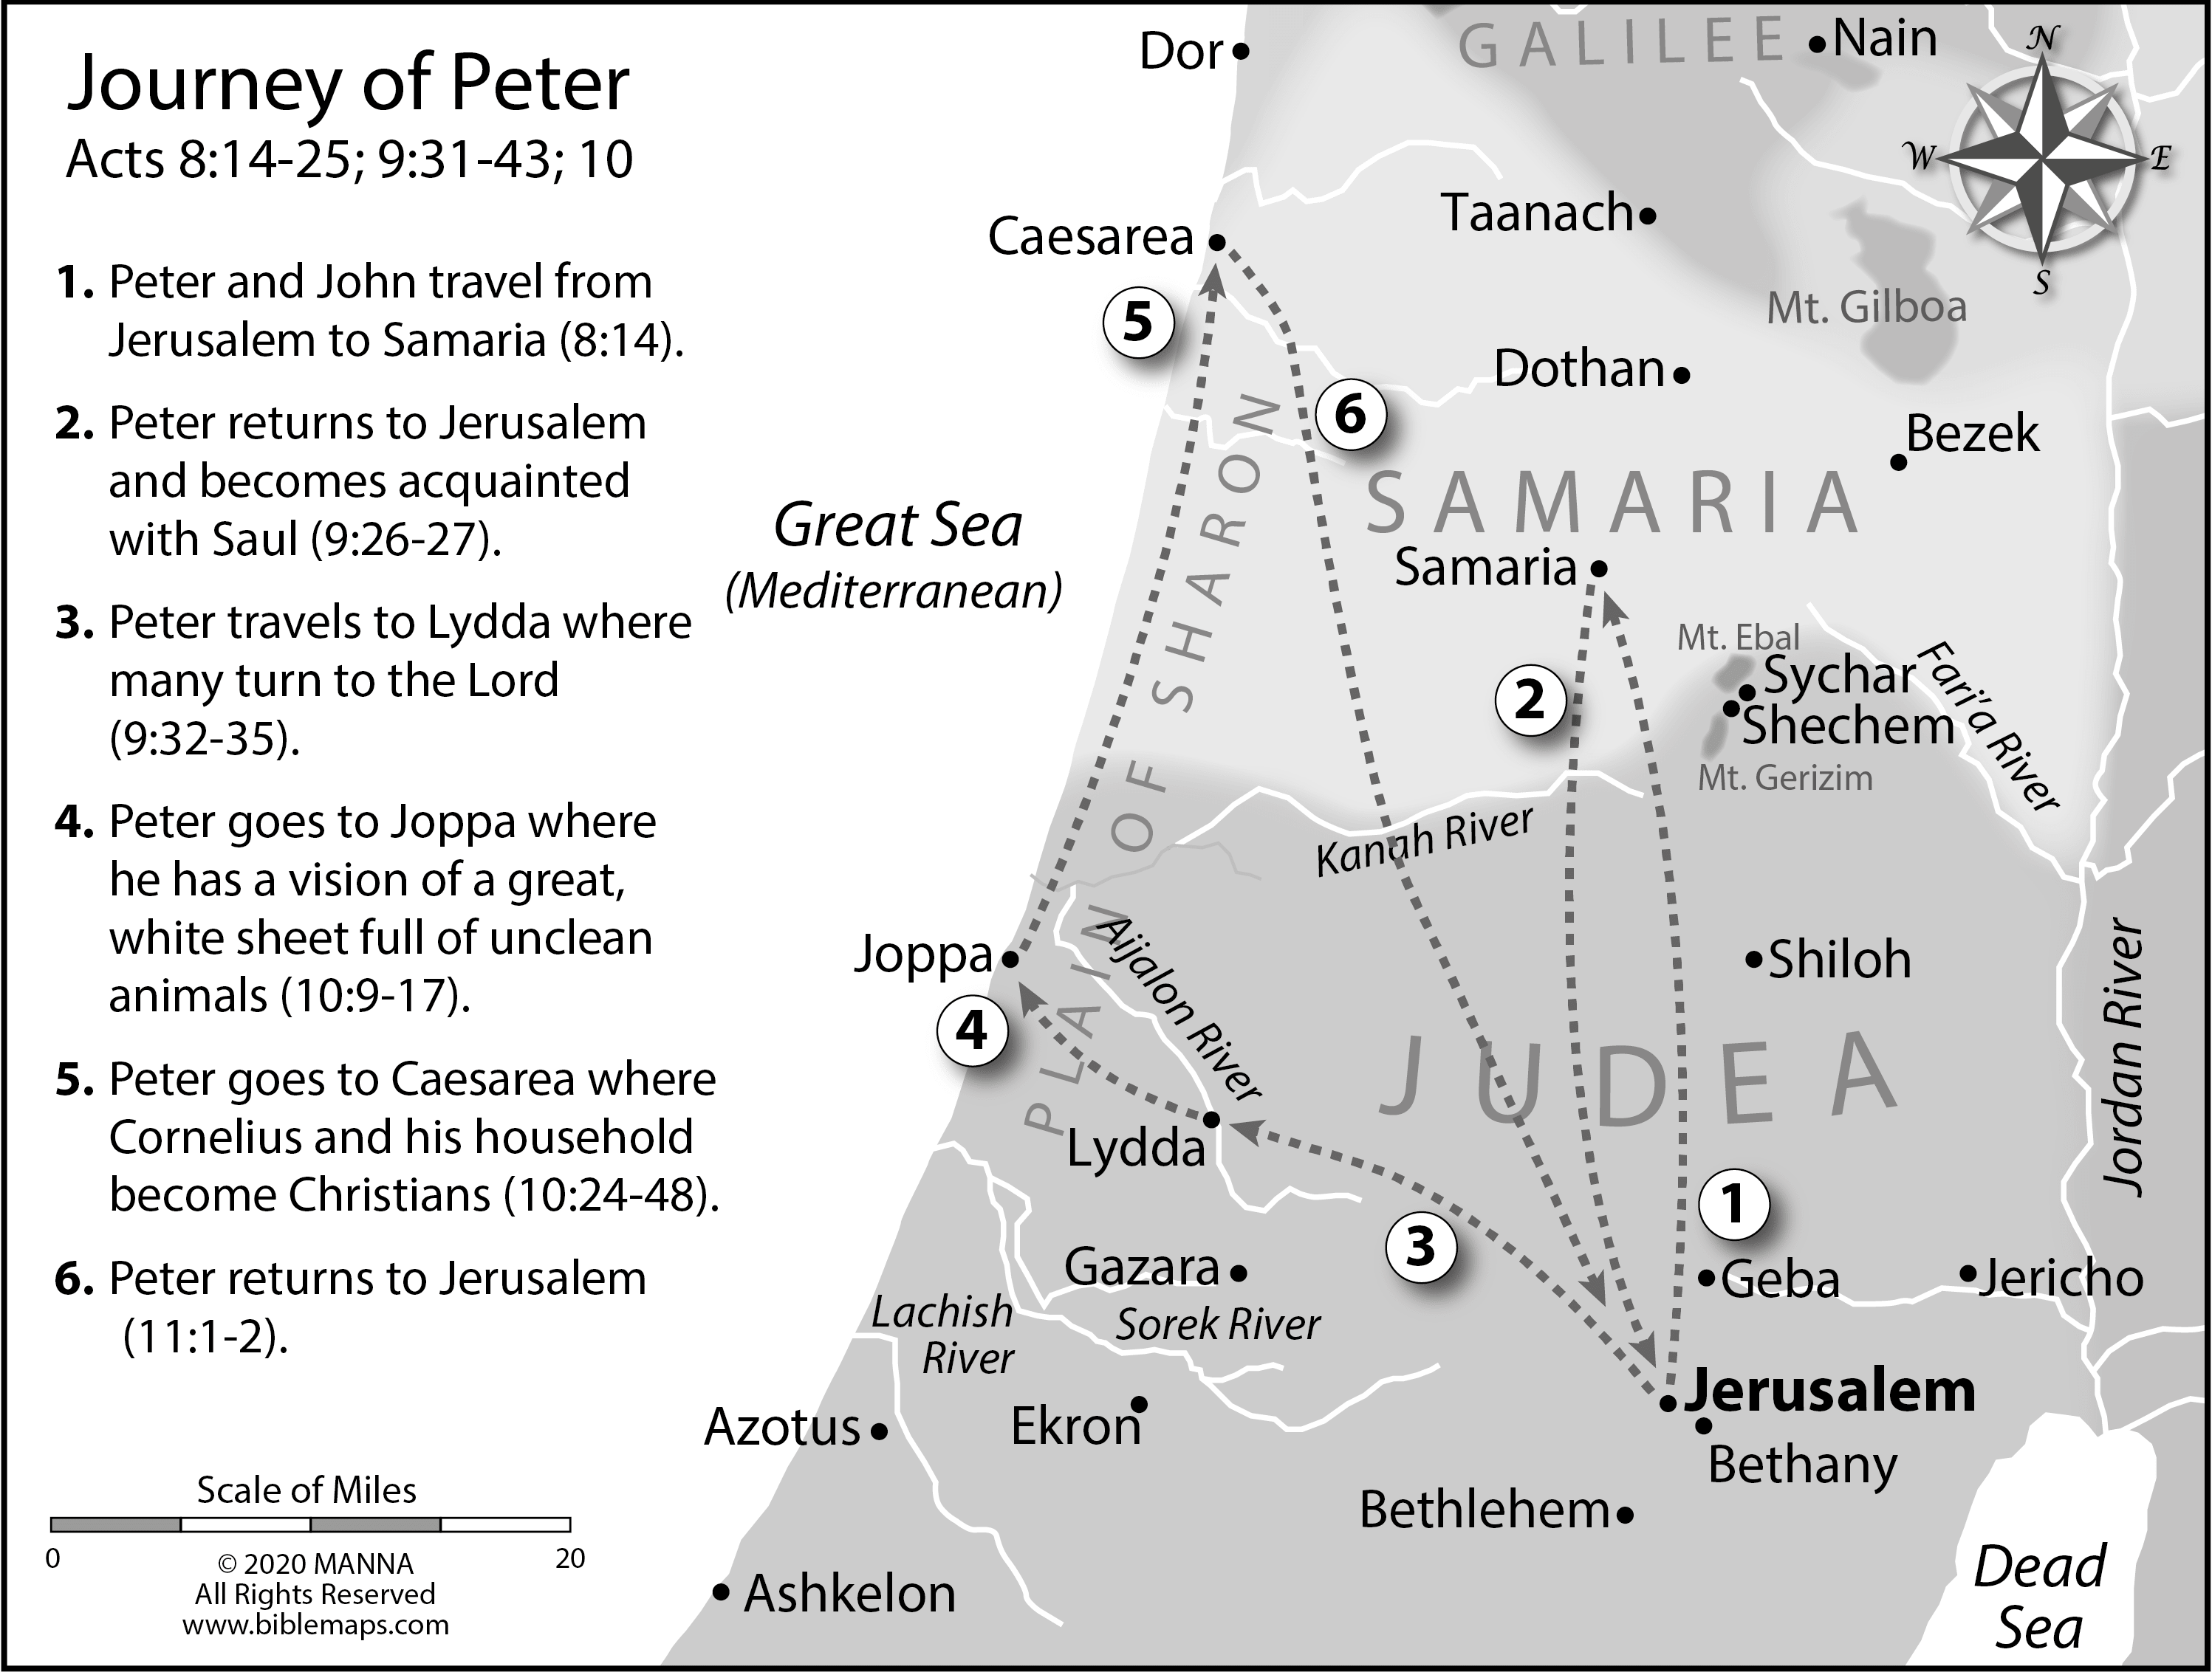
Verses 32 thru 35 (Peter Heals Aeneas)‬‬‬‬‬
Peter decides to visit some of the other churches that had been started by the disciples who had scattered after Stephen was martyred. Peter’s journey began in chapter 8 when he had gone to visit the believers in Samaria and now he is going to Lydda which is about 25 miles northwest of Jerusalem. We know that Philip traveled through this town when he was going from Azotus to Caesarea and he may have started the churches in this area. While Peter is in Lydda, he meets a man named Aeneas who has been bedridden for 8 years. Peter simply tells Aeneas, “Jesus Christ heals you!” Instantly this man who has been paralyzed for 8 years is miraculously healed and Peter tells him to get up and roll up his mat. This story sounds very similar to the story in Luke 5:17-26 where Jesus has healed a lame man, and he tells him to roll up his mat and walk. Peter and John had also healed a lame man at the Beautiful Gate back in chapter 3 who had been lame for more than 40 years. These miracles of healing would continue throughout the New Testament, leaving no doubt that the power of Jesus was still working in the believers, and it continues still today. Do you know of a healing miracle?
Verses 36 thru 41 (Peter Raises Tabitha from the Dead)‬‬‬‬‬
While Peter is in Joppa, he gets an urgent request from two men to come to the seaport town of Joppa, which may have also been visited by Philip. There was a disciple named Tabitha living in Joppa who was always ministering to the poor and she had died from a recent illness. The common practice during those days, was to wash the body and bury someone as soon as possible. They did not have the embalming methods that we have today, and a body needed to be buried before it started to decompose. Joppa was about 15 miles from Lydda where Peter was at, so it probably took these men two days to go get Peter and bring him back to Joppa.
When Peter arrives at Tabitha’s home, he is met by a group of widows who are mourning, and they show him all of the beautiful clothes that Tabitha made for them. This also lets us know a little more about Tabitha’s role in the church and she may have been placed in charge of caring for the widows and orphans in that community. Peter tells everyone to leave the house, and he goes to the upper room where Tabitha’s body has been placed. He kneels down beside the bed and prays, which is what we all should do in challenging situations. Peter turns to Tabitha and commands her to get up!
Tabitha opens her eyes and sits up in the bed, and then Peter took her hand and helped her to her feet. He calls in all of the people who were anxiously waiting outside and they all begin to rejoice over this great miracle. Although Jesus had raised several people from the dead, this is the first time one of the believers had the power to raise someone back to life thru the name of Jesus. The word of this great miracle spreads fast, and many of the Jews in that area became believers. This increased the number of people in the church and helps to spread the gospel even more.
Verses 42 and 43 (Peter Stays with Simon)‬‬‬‬‬
Peter decides to stay in Joppa for a while and he stays in the house of a man named Simon. We are told that Simon was a tanner which is significant. Being a tanner meant that he was constantly touching dead animals and made him someone who was “unclean” to the Jews. During that time, a tanner was made to live at least 75 feet outside of the town boundaries due to his unclean work. Why did Peter, who would have also been considered unclean by living in this house, decide to stay with Simon? The answer lies ahead in chapter 10.
Read Chapter 10 before our next class.

