Acts Chapter 13– Test Your Knowledge Part 1

- What seaport town did Barnabas and Saul go to when they left Antioch in this chapter?
- Pamphylia
- Paphos
- Salamis
- Seleucia

- Who called Barnabas and Saul to go on their missionary journey?
- Peter
- Holy Spirit
- Simeon
- Jesus

- What was the name of the proconsul/governor of Cyprus?
- Sergius Paulus
- Elymas
- Bar-Jesus
- Manaen

- In what town did John Mark leave Paul and Barnabas and return to Jerusalem?
- Perga
- Antioch
- Salamis
- Paphos

- Where did Paul and Barnabas go after they left Perga?
- Antioch of Pisidia
- Salamis
- Paphos
- Jerusalem

Bonus (20 Points): How was John Mark related to Barnabas ? ____________

Grade:_____ (20 Points for each correct answer)

The Acts of the Apostles – Chapter 13 Part 1

Last week we read about James getting executed by Herod Agrippa I and how Peter was set free from jail by an angel. We also read about the gruesome death of Herod after he accepted that the people called him a god and he was eaten internally by worms. At the end of chapter 12 the gospel continued to grow, and Barnabas and Saul return to Antioch with John Mark.

Barnabas and Saul Are Commissioned
¹Among the prophets and teachers of the church at Antioch of Syria were Barnabas, Simeon (called “the black man”), Lucius (from Cyrene), Manaen (the childhood companion of King Herod Antipas), and Saul. ² One day as these men were worshiping the Lord and fasting, the Holy Spirit said, “Appoint Barnabas and Saul for the special work to which I have called them.” ³ So after more fasting and prayer, the men laid their hands on them and sent them on their way.

Paul’s First Missionary Journey
⁴ So Barnabas and Saul were sent out by the Holy Spirit. They went down to the seaport of Seleucia and then sailed for the island of Cyprus. ⁵ There, in the town of Salamis, they went to the Jewish synagogues and preached the word of God. John Mark went with them as their assistant.
⁶ Afterward they traveled from town to town across the entire island until finally they reached Paphos, where they met a Jewish sorcerer, a false prophet named Bar-Jesus. ⁷ He had attached himself to the governor, Sergius Paulus, who was an intelligent man. The governor invited Barnabas and Saul to visit him, for he wanted to hear the word of God. ⁸ But Elymas, the sorcerer (as his name means in Greek), interfered and urged the governor to pay no attention to what Barnabas and Saul said. He was trying to keep the governor from believing.
⁹ Saul, also known as Paul, was filled with the Holy Spirit, and he looked the sorcerer in the eye. ¹⁰ Then he said, “You son of the devil, full of every sort of deceit and fraud, and enemy of all that is good! Will you never stop perverting the true ways of the Lord? ¹¹ Watch now, for the Lord has laid his hand of punishment upon you, and you will be struck blind. You will not see the sunlight for some time.” Instantly mist and darkness came over the man’s eyes, and he began groping around begging for someone to take his hand and lead him.
¹² When the governor saw what had happened, he became a believer, for he was astonished at the teaching about the Lord. ¹³ Paul and his companions then left Paphos by ship for Pamphylia, landing at the port town of Perga. There John Mark left them and returned to Jerusalem. ¹⁴ But Paul and Barnabas traveled inland to Antioch of Pisidia.
Verses 1 thru 3 (Commissioned by the Holy Spirit)‬‬‬‬‬
Chapter 13 starts off by giving us a list of teachers and prophets who were at the church in Antioch of Syria. We are familiar with Barnabas and Saul, and it is no surprise that they are mentioned in this list. Three other men are also mentioned, but we know very little about them. Simeon was called Niger in the KJV, NIV and NASB, but the NLT calls him the “black man”. Niger in Latin means black, so the NLT translation is valid, and some scholars believe that this may have been the same person named in Luke 23:26 that carried Jesus’ cross up the hill to Golgotha. Manaen was a childhood friend of Herod Antipas who was the same person who had John the Baptism beheaded. What a difference in the way these two men would become. One was spreading the gospel, and another was killing the prophets. Nothing else is known about Lucius, but he was obviously a prominent teacher and prophet like the other men.
In verse two, the Holy Spirit calls Barnabas and Saul to a new mission. This happened when they were fasting and seeking the will of God. Fasting is a powerful tool that we should use when seeking the will of God and it was obviously being used in the early church. The leaders of the church in Antioch prayed for Barnabas and Saul and laid hands on them to commission them for the work that the Holy Spirit had called them to do. This was the would be the first of three missionary journeys that Saul would be sent out on.
Verses 4 and 5 (The Island of Cyprus)‬‬‬‬‬
Barnabas and Saul leave Antioch and take a short walk down to the seaport town of Seleucia where they book passage on a ship for the island of Cyprus. The 130 mile trip from Selecia to Cyprus by ship likely only took a few days. Ships during that time were powered by the wind in the sails or by oars and, depending on the wind a boat could travel up to 100 miles per day.
We do not know why they decided to go to Cyprus first, but we do know that this is where Barnabas was from and he may have wanted to preach to his home country. When they get to Salamis, Barnabas and Saul find the local synagogue and start preaching the Word of God to the Jews. Barnabas and Saul had taken John Mark with them on this journey, and he was there helping them minister to the people. We know from Colossians 4:10 that John Mark was the cousin of Barnabas and that may have been why he went with them to help.
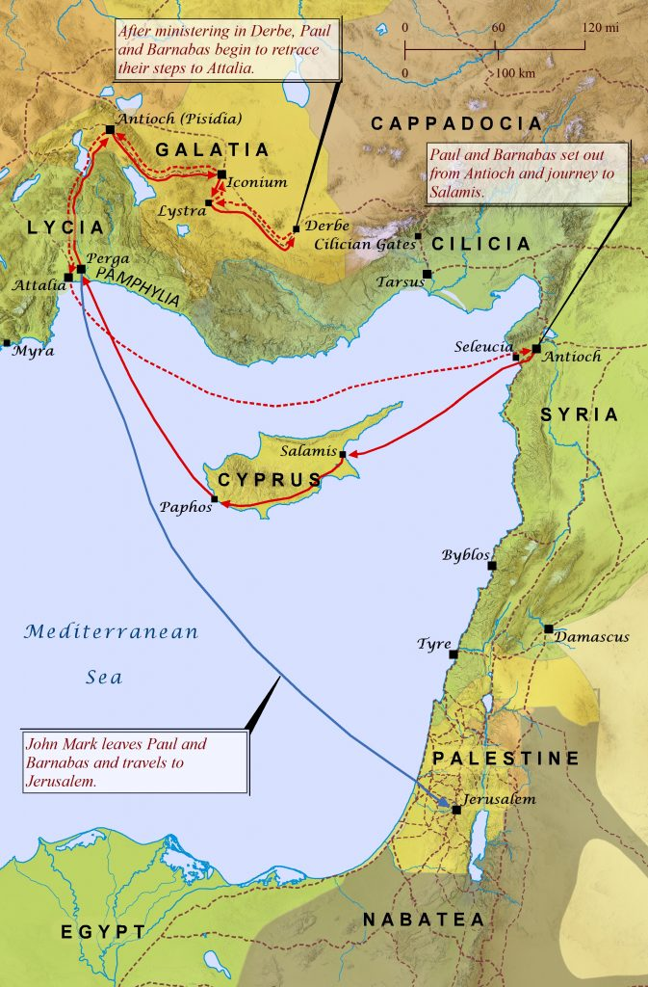

Verses 6 thru 8 (The Magician)‬‬‬‬‬
Barnabas and Saul leave Salamis and travel from the east coast to west coast across the island (95 miles) and stop in every town that they came to and preach the Gospel to the people of Cyprus. When they get to the west coast of Cyprus, they stay in the capitol city of Paphos that was known for immorality and spiritual wickedness. Luke tells us that they meet two different men at Paphos with different purposes. Bar-Jesus, also called Elymas, who is a magician, sorcerer and a false prophet and an intelligent man named Sergius Paulus who is the Roman proconsul or governor of Cyprus. The governor had probably heard that Barnabas and Saul were going across the island preaching to the people and the governor want to her the “Good New” that these men were preaching. He was actively seeking the Word of God and he was so anxious to met these two preachers, that he requested that they come to him so that he could personally hear their message.
Bar-Jesus had found favor with the governor and was probably enjoying a life of luxury as a servant of the governor. He tried to persuade the governor not to listen to Barnabas and Saul and actively opposed their message. He was trying to keep the governor from believing the gospel probably because he knew that he would lose his influence with the governor and might loose his source of income. It is not uncommon for us to encounter similar spiritual opposition when we are sharing the gospel. Often times people who are opposed to the gospel do not want to see other people get saved. Why would someone try to stop people from believing in Jesus and receive an eternal life in Heaven?
Verses 9 thru 12 (Apostle Paul and Power of the Holy Spirit)‬‬‬‬‬
Verse 9 for the first time tells us that Saul was also called Paul and for the rest of his time in the scripture he will be known by his Roman name. Paul was a Roman citizen and would spend most of his time throughout the rest of scripture preaching to the gentiles on his missionary journeys. Paul gets irritated with this false prophet interrupting him while he is trying to witness to the governor, and he turns his attention from the governor to Bar-Jesus.
Paul is filled with the power of the Holy Spirit and he turns to Bar-Jesus and calls him deceitful, a fraud, son of the devil and an enemy of righteousness. Paul has had enough of this evil spirit and through the power of the Holy Spirit, Paul blinds him to keep him from hindering the gospel. The false prophet with no real power has met a true prophet and has “seen” the real power of God. Bar-Jesus stumbles around in utter darkness and cries out for someone to help him get out of there. Seeing the power and judgement of God firsthand and hearing the Word of the Lord, the governor instantly believes in Christ and accepts him as the Messiah. Wasn’t there another story of a magician/sorcerer in Acts 8:9-25? Wasn’t someone else blinded in Acts 9?
Verses 13 and 14 (John Mark Returns to Jerusalem)‬‬‬‬‬
After preaching to the people of Cyprus, we are told that Paul and “his party” set sail for Pamphylia. Up until this point in Acts, we have always heard about Barnabas and Paul with Barnabas listed first. This was because Barnabas was always seen as the leader or chief person in the group, but now Paul appears to become the main person in the group, and he is now their leader.
When they reach the city of Perga in modern day Turkey, John Mark decides to leave the group and return to Jerusalem. Although we are not told why he depart, but we know that he was still a young man. and he may have become homesick and weary of traveling or it may have been that he did not like Paul taking over the group. We find out later on in Acts 15, that Paul resented John Mark for abandoning the group and it would seem that John Mark’s departure was not on good terms. Paul would later on reconcile with Mark and Paul would tell Timothy to bring Mark to him because “he will be helpful to me in my ministry”. (2 Tim. 4:11)
After they had ministered in Perga Paul and Barnabas traveled north to Antioch of Pisida.
Read Chapter 13 versus 15-52 before our next class.

