Romans Chapter 10 – Test Your Knowledge

- Paul was angry with the Jews and did not want them to be saved.
- True
- False
- Paul said the Jews did not know the ___________ of God
- Faith
- Righteousness
- Justice
- Mind

- Paul said there is no difference between
- Pharisees and Sadducees
- Greeks and Pagans
- Jews and Gentiles
- Romans and Galatians

- Paul stated that “All who call on the name of the Lord shall be saved.”
- True
- False

- Paul said that all those who bring the good news (carry the Gospel) have _____________
- Dirty feet
- A big responsibility
- Sore feet
- Beautiful feet

Bonus (20 Points): What comes by hearing the message? And the message is heard through the?
_____________________________________________________________________________

Grade: _______ (20 Points for each correct answer)

Recap from the Last Class
In Chapter 9 Paul dealt with Israel’s unbelief in Christ, the Gospel. Paul expressed his great sorrow in that problem. However, God has mercy and has a plan of Salvation for all – but, God has mercy on whom he wants to have mercy. God hardened Pharaoh’s heart as an example for all those who will reject Christ. Paul also addressed that the potter has the right to create, break, and recreate what he wants. The chapter ended by discussing the objects of Gods wrath and mercy.
Romans – Chapter 10 (NIV)
Brothers and sisters, my heart’s desire and prayer to God for the Israelites is that they may be saved. ² For I can testify about them that they are zealous for God, but their zeal is not based on knowledge. ³ Since they did not know the righteousness of God and sought to establish their own, they did not submit to God’s righteousness. ⁴ Christ is the culmination of the law so that there may be righteousness for everyone who believes.
⁵ Moses writes this about the righteousness that is by the law: “The person who does these things will live by them.”^{[a]} ⁶ But the righteousness that is by faith says: “Do not say in your heart, ‘Who will ascend into heaven?’”^{[b]} (that is, to bring Christ down) ⁷ “or ‘Who will descend into the deep?’”^{[c]} (that is, to bring Christ up from the dead). ⁸ But what does it say? “The word is near you; it is in your mouth and in your heart,”^{[d]} that is, the message concerning faith that we proclaim: ⁹ If you declare with your mouth, “Jesus is Lord,” and believe in your heart that God raised him from the dead, you will be saved. ¹⁰ For it is with your heart that you believe and are justified, and it is with your mouth that you profess your faith and are saved. ¹¹ As Scripture says, “Anyone who believes in him will never be put to shame.”^{[e]} ¹² For there is no difference between Jew and Gentile—the same Lord is Lord of all and richly blesses all who call on him, ¹³ for, “Everyone who calls on the name of the Lord will be saved.”^{[f]}
¹⁴ How, then, can they call on the one they have not believed in? And how can they believe in the one of whom they have not heard? And how can they hear without someone preaching to them? ¹⁵ And how can anyone preach unless they are sent? As it is written: “How beautiful are the feet of those who bring good news!”^{[g]}
¹⁶ But not all the Israelites accepted the good news. For Isaiah says, “Lord, who has believed our message?”^{[h]} ¹⁷ Consequently, faith comes from hearing the message, and the message is heard through the word about Christ. ¹⁸ But I ask: Did they not hear? Of course they did: “Their voice has gone out into all the earth, their words to the ends of the world.”^{[i]}
¹⁹ Again I ask: Did Israel not understand? First, Moses says, “I will make you envious by those who are not a nation; I will make you angry by a nation that has no understanding.”^{[j]}
²⁰ And Isaiah boldly says, “I was found by those who did not seek me; I revealed myself to those who did not ask for me.”^{[k]}
²¹ But concerning Israel he says, “All day long I have held out my hands to a disobedient and obstinate people.”
COMMENTARY:
Verses 1-21 A Continuation of Chapter 9:30-33 – The Human Responsibility
V1-8 Paul’s heart’s desire and prayer to God & they did not submit – For more detailed commentary of this statement see the attached handout “Israel in God’s Plan of Salvation.”
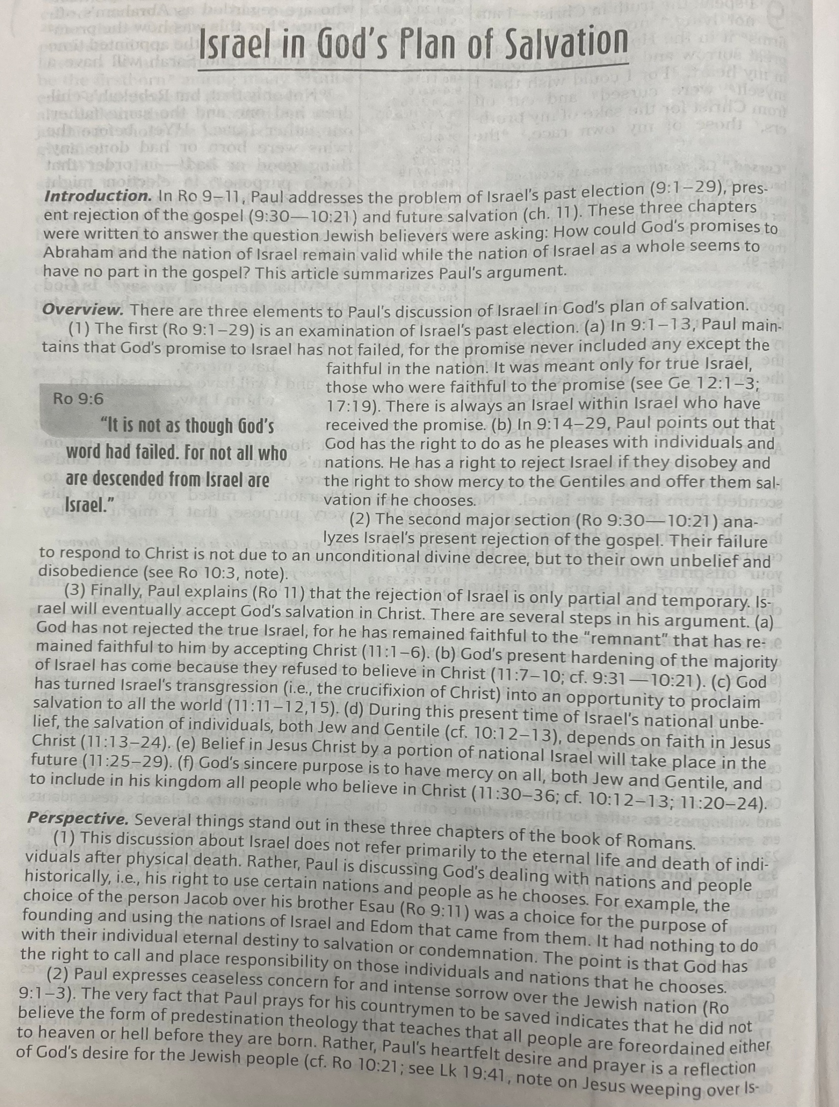
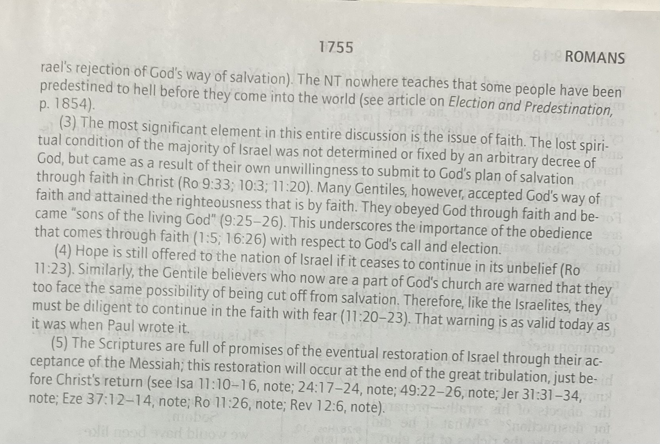
V4 Climax of the Covenant – Christ is the completion of the Law (Torah), the end of a goal. (Gk – Telos = goal, Nomou = law). The Torah is vindicated in Christ as is God vindicated in Christ) vindicated = clear of suspicion, blame
V9-10 Confess … believe in your heart – The essentials of salvation are summarized here. They center on belief in the Lordship of Christ and His bodily resurrection. Faith involves not only believing the truth about Jesus with our mind, but also responding with our heart (our inner being) and our whole person. Faith must also involve committing oneself publicly to Jesus as Lord, both in word and deed.
V9 Confess Jesus is Lord. The earliest creed or confession of the NT church was not “Jesus is Savior,” but “Jesus is Lord” (Acts 8:16; 19:5; 1 Cor 12:3). Jesus Christ is specifically called Savior 16 times in the NT and Lord more than 450 times.
- The current teaching in some evangelical circles that Jesus can be one’s Savior without necessarily being one’s Lord is found nowhere in the NT. No one can receive Jesus as Savior without receiving Him as Lord. This is an essential ingredient in apostolic preaching (Acts 2:26-40). This explains why many want forgiveness without His leadership – they want to live like they want. Thus just their belief in Christ is not enough. Some want out of trouble but not the Lordship of Jesus Christ to rein over their lives.
- “Lord” (Gk - kyrios) means having power, dominion, authority and the right to master. To confess “Jesus is Lord” is to declare Him to be equal with God (v13; John 20:28; Acts 2:36; Heb 1:10) and worthy of power (Rev 5:12), worship (Phil 2:10-11), trust (John 14:1; Heb 2:13), obedience (Heb 5:9) and prayer (Acts 7:59-60; 2 Cor 12:8).
- When NT Christians called Jesus “Lord,” this was not just an outward profession but an inward attitude of the heart (1 Pet 3:15) by which they made Christ and His Word Lord over all of life (Luke 6:46-49; John 15:14). Jesus must be Lord at home and in the church and in all our relationships, as well as in intellectual, financial, educational, recreational and vocational spheres – in fact, in all areas of life (Rom 12:1-2; 1 Cor 10:31).
V9 God raised Him from the dead – Anyone denying Christ’s bodily resurrection cannot legitimately claim to be a Christian. He or she is still an unbeliever, for the death and resurrection of Christ is the central event in salvation (Rom 1:4; 4:25; 5:10,17; 6:4-10; 8:11, 34).
What did you learn from this class? ________________________________________________________________________________________________________________________________________________________________________________________________________________________________________________________________________________________________________________________________

