Acts Chapter 11– Test Your Knowledge

- Why were the Jewish believers in Jerusalem criticizing Peter in this chapter?
- He entered the home of Gentiles
- He preached on the Sabbath
- He ate with the Gentiles
- Only “A” and “B”

- How many men went with Peter from Joppa to Caesarea?
- 3
- 4
- 5
- 6

- When the believers in Jerusalem heard about the growth of the church in Antioch, who did they send?
- Timothy
- Barnabus
- Saul
- Peter

- In what city were the believers first called Christians?
- Cyprus
- Antioch
- Cyrene
- Phoenicia

- Who predicted that a great famine was coming in this chapter?
- Agabus
- Saul
- Barnabus
- Timothy

Bonus (20 Points): Who took the gift from Antioch back to the elders in Jerusalem? ___________ and ____________

Grade:_____ (20 Points for each correct answer)
The Acts of the Apostles – Chapter 11

In chapter 10 we read about Peter visiting the house of a Roman centurion named Cornelius. Cornelius had a vision about Peter and had sent some men to get him from Joppa. Peter had a vision of a sheet being let down from heaven with unclean animals in it, and a voice had told him to arise, kill and eat. Peter says “no” and says he has never eaten anything that was unclean. The voice tells him not to call something unclean that God has made clean. When Peter visits Cornelius’ house and starts to preach, the Holy Spirit falls on the Gentiles and everyone is amazed.

Peter Explains His Actions
¹ Soon the news reached the apostles and other believers in Judea that the Gentiles had received the word of God. ² But when Peter arrived back in Jerusalem, the Jewish believers criticized him.³ “You entered the home of Gentiles and even ate with them!” they said.
⁴ Then Peter told them exactly what had happened. ⁵ “I was in the town of Joppa,” he said, “and while I was praying, I went into a trance and saw a vision. Something like a large sheet was let down by its four corners from the sky. And it came right down to me. ⁶ When I looked inside the sheet, I saw all sorts of tame and wild animals, reptiles, and birds. ⁷ And I heard a voice say, ‘Get up, Peter; kill and eat them.’
⁸ “‘No, Lord,’ I replied. ‘I have never eaten anything that our Jewish laws have declared impure or unclean.’
⁹ “But the voice from heaven spoke again: ‘Do not call something unclean if God has made it clean.’ ¹⁰ This happened three times before the sheet and all it contained was pulled back up to heaven.
¹¹ “Just then three men who had been sent from Caesarea arrived at the house where we were staying. ¹² The Holy Spirit told me to go with them and not to worry that they were Gentiles. These six brothers here accompanied me, and we soon entered the home of the man who had sent for us. ¹³ He told us how an angel had appeared to him in his home and had told him, ‘Send messengers to Joppa, and summon a man named Simon Peter. ¹⁴ He will tell you how you and everyone in your household can be saved!’
¹⁵ “As I began to speak,” Peter continued, “the Holy Spirit fell on them, just as he fell on us at the beginning. ¹⁶ Then I thought of the Lord’s words when he said, ‘John baptized with water, but you will be baptized with the Holy Spirit.’ ¹⁷ And since God gave these Gentiles the same gift he gave us when we believed in the Lord Jesus Christ, who was I to stand in God’s way?”
¹⁸ When the others heard this, they stopped objecting and began praising God. They said, “We can see that God has also given the Gentiles the privilege of repenting of their sins and receiving eternal life.”

The Church in Antioch of Syria
¹⁹ Meanwhile, the believers who had been scattered during the persecution after Stephen’s death traveled as far as Phoenicia, Cyprus, and Antioch of Syria. They preached the word of God, but only to Jews. ²⁰ However, some of the believers who went to Antioch from Cyprus and Cyrene began preaching to the Gentiles about the Lord Jesus. ²¹ The power of the Lord was with them, and a large number of these Gentiles believed and turned to the Lord.
²² When the church at Jerusalem heard what had happened, they sent Barnabas to Antioch. ²³ When he arrived and saw this evidence of God’s blessing, he was filled with joy, and he encouraged the believers to stay true to the Lord. ²⁴ Barnabas was a good man, full of the Holy Spirit and strong in faith. And many people were brought to the Lord.
²⁵ Then Barnabas went on to Tarsus to look for Saul. ²⁶ When he found him, he brought him back to Antioch. Both of them stayed there with the church for a full year, teaching large crowds of people. (It was at Antioch that the believers were first called Christians.)
²⁷ During this time some prophets traveled from Jerusalem to Antioch.²⁸ One of them named Agabus stood up in one of the meetings and predicted by the Spirit that a great famine was coming upon the entire Roman world. (This was fulfilled during the reign of Claudius.) ²⁹ So the believers in Antioch decided to send relief to the brothers and sisters in Judea, everyone giving as much as they could. ³⁰ This they did, entrusting their gifts to Barnabas and Saul to take to the elders of the church in Jerusalem.
Verses 1 thru 3 (Peter Faces Criticism)‬‬‬‬‬
After Peter stayed at Cornelius’ house for a few days, he decided to travel back to Jerusalem to share the good news of the Gentiles getting saved and receiving the Holy Spirit. This should have been a time for great joy knowing that the Gentiles had received the Holy Spirit, but instead Peter is called before his Jewish/circumcised brothers and asked to explain his actions. Although these men were saved, they were offended that Peter had broken with the tradition of remaining separate from the unclean Gentiles. In other words, they might have accepted that the Gentiles could be saved, but they would still be a separate class of people and never be “as good as” the Jews. Changing a culture is one of the most difficult things to do, but that doesn’t mean that we shouldn’t try to change it.
Verses 4 thru 18 (Peter Defends His Actions)‬‬‬‬‬
Peter’s wisdom begins to show through again and he does not try to defend himself from their pious accusations. Often when we are attacked, the first thing we do is try to defend ourselves or shift the blame to someone else (Adam blamed Eve and Eve blamed the serpent). Peter repeated the story exactly as it happened. He told them the truth, the whole truth and nothing but the truth! He tells them the story about his vision of the sheet with all of the unclean animals, and how God had told him to arise kill and eat. After Peter told them about how he refused to eat anything unclean, that God told him not to consider anything unclean or unholy that He had made clean and holy.
Peter goes on to tell them about the men coming from Caesarea to get him and how the voice in the vision had told him to go with them. Peter also adds another detail to the story when he tells them that “these six brothers” accompanied him to Cornelius’ house. These six men were likely other Jewish believers, and they were his witnesses of what had taken place. He also said the “we” entered the house letting them know that not only he himself had entered the house, but that these other men had also went into Cornelius’ home. Peter explains the vision that Cornelius had, and how his vision had told them that Peter would tell them how to get saved. Then Peter tells them how the Holy Spirit fell on the Gentiles “just as He had fallen on us at the beginning.”
Peter now tells them since God had given these Gentiles that “same gift he gave us when we believed in the Lord Jesus Christ, who was I to stand in God’s way?” Peter’s answer seems to have completely convinced them (for now) and they began praising God for this great gift that He had given to the Gentiles. This would seem to have sealed the deal and that the Gentiles would have been fully accepted, but we will learn later on in chapter 15, that this issue would still cause trouble in the church. Peter refused to stand in God’s way, but do we still stand in God’s way today?
Verses 19 thru 21 (Spreading the Gospel)‬‬‬‬‬
Luke changes the scene in verse 19 and seems to take a step backwards in time. He tells us that the believers who had been scattered by the stoning of Stephen (Acts 7) had started to witness to the Jews in the towns where they had fled. But some very brave men had gone to Antioch and started to preach to the Gentiles. Antioch was the capitol of Syria and a town of about 500,000 people. It was the third largest city in the Roman empire at that time and the Gentiles in Antioch were open to the Gospel. These brave men began preaching to the Gentiles about the Good News of Jesus Christ and large numbers of them would come to know Jesus as their Lord and Savior.
Verses 22 thru 26 (Barnabus and Saul at Antioch)‬‬‬‬‬
When the believers in Jerusalem heard about how great numbers of the Gentiles had come to faith in Jesus, they sent Barnabas to check it out. This is the third time we have met Barnabus in Acts. The first time was in Acts 4 when he gave a great gift to the church and again in Acts 9 when he stepped forward and stood as a witness for Saul. Barnabus was a Levite from the island of Cyprus, and he had been sent on an important mission.
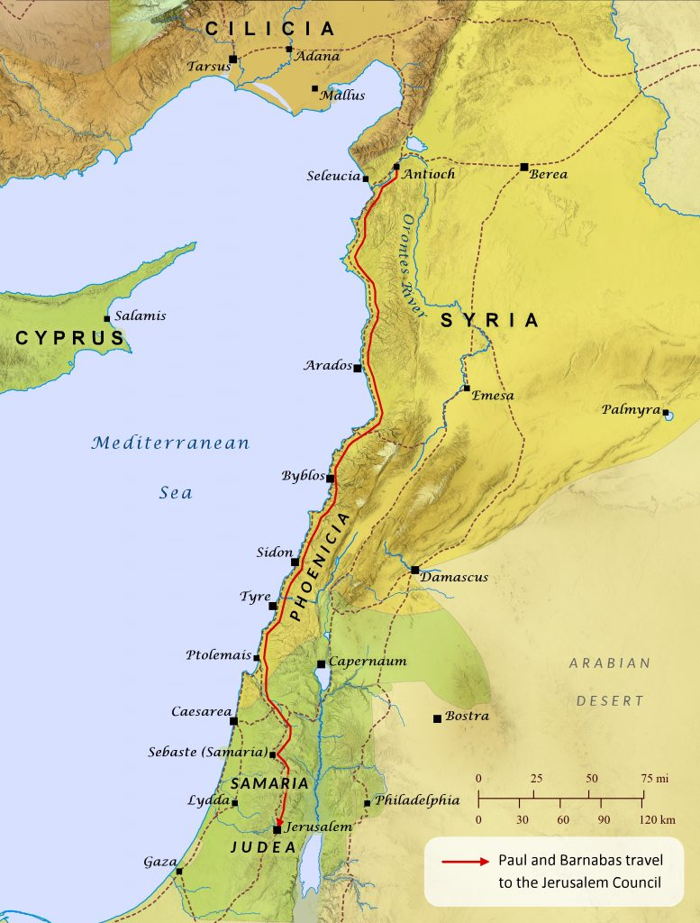
When Barnabas arrives in Antioch and sees how open they are to the Gospel, he decides to take a short trip to Tarsus to get his old friend Saul. Saul had fled to this area after the Jews in Jerusalem had tried to kill him and he has been preaching in his hometown for about 10 years. Barnabas and Saul travel back to Antioch and spend the next year preaching to the believers in that town and creating a thriving church. It was in Antioch where people started to call the believers Christians and that is still the name that we claim today. What does being a Christian mean to you? What does it mean to others around you? If you never specifically told someone that you were a Christian, would they know it by your actions? Or would they be surprised that you call yourself a Christian?
Verses 27 thru 30 (Gift for the Believers in Jerusalem)‬‬‬‬‬
The gifts of the Spirit were active in the early church and a prophet by the name of Agabus had come from Jerusalem to Antioch. While he was there in one of their church services, Agabus prophesies that there will be a great famine throughout all of the known world. This prophetic message would come true during the reign of Claudius Caesar and most of Rome, Greece, Egypt and Judea would have a famine that would cause many to starve. Although we are not told who’s idea it was, the disciples decided to take up an offering and send a gift to the believers in Jerusalem. Barnabus was originally introduced by Luke as the “Son of Encouragement”, and we know that he had a heart of giving. He may have been the one who came up with the idea of giving them this gift, but all of the believers decided to join in. It is important to know that not everyone gave the same amount, but everyone gave according to their ability.
Giving is an individual act, but when we give generously as a congregation, we can do amazing things. Planting churches in Laos, Cambodia and Thailand could not have been done by one person in our church. Together as the body of Christ, we were able to give generously and help spread the gospel to the ends of the earth and to help those in need.
The church in Antioch decided that they would send Barnabas and Saul as their official representatives back to Jerusalem, and they would carry this gift to the church elders. This is the first time that “elders” are mentioned in the bible, and it also shows how the church was starting to get organized. These elders would have taken the gift that had been collected in Antioch and probably given it to the deacons to use in the daily food distribution of those who were suffering from the famine.
Read Chapter 12 before our next class.

