Acts Chapter 14 – Test Your Knowledge

- What towns did Paul and Barnabas go to in this chapter?
- Iconium
- Perga
- Derbe
- All of the above
- Only “A” and “C”

- What miracle was performed in this chapter?
- 5000 men were fed from 5 loaved of bread and 2 fish
- Paul raises a young man back to life
- A blind man received his sight
- A crippled man was healed

- When the people saw the miracle in this chapter, they called Barnabas Jupiter/Zeus because they thought he was a god in human form.
- True
- False
- Neither True nor False

- What happened to Paul in this chapter
A. He is whipped
B. He is beaten
C. He is stoned
D. All of the above

- Who did Paul and Barnabas appoint in the churches in that area in this chapter?
- Deacons
- Apostles
- Elders
- Singers

Bonus (20 Points): Where did Paul and Barnabas sail too at the end of this chapter? ____________

Grade:_____ (20 Points for each correct answer)

The Acts of the Apostles – Chapter 14

Last week we learned about Paul’s visit to the town of Antioch in Pisidia. There Paul and Barnabas preached in the synagogue and won over great numbers of both Jews and Gentile converts to Judaism. The next week when Paul and Barnabas returned to preach again, the entire city showed up and the Jews became jealous and argued against them. Since the Jews had rejected the gospel message, Paul says that he would now take it to the Gentiles. This made the Gentiles very happy, but the Jews decided to run the two men out of town. Paul shakes the dust from his sandals in Antioch and travels on to the town of Iconium.
Paul and Barnabas in Iconium
¹The same thing happened in Iconium. Paul and Barnabas went to the Jewish synagogue and preached with such power that a great number of both Jews and Greeks became believers. ² Some of the Jews, however, spurned God’s message and poisoned the minds of the Gentiles against Paul and Barnabas. ³ But the apostles stayed there a long time, preaching boldly about the grace of the Lord. And the Lord proved their message was true by giving them power to do miraculous signs and wonders. ⁴ But the people of the town were divided in their opinion about them. Some sided with the Jews, and some with the apostles.
⁵ Then a mob of Gentiles and Jews, along with their leaders, decided to attack and stone them. ⁶ When the apostles learned of it, they fled to the region of Lycaonia—to the towns of Lystra and Derbe and the surrounding area. ⁷ And there they preached the Good News.

Paul and Barnabas in Lystra and Derbe
⁸ While they were at Lystra, Paul and Barnabas came upon a man with crippled feet. He had been that way from birth, so he had never walked. He was sitting ⁹ and listening as Paul preached. Looking straight at him, Paul realized he had faith to be healed. ¹⁰ So Paul called to him in a loud voice, “Stand up!” And the man jumped to his feet and started walking.
¹¹ When the crowd saw what Paul had done, they shouted in their local dialect, “These men are gods in human form!” ¹² They decided that Barnabas was the Greek god Zeus and that Paul was Hermes, since he was the chief speaker. ¹³ Now the temple of Zeus was located just outside the town. So the priest of the temple and the crowd brought bulls and wreaths of flowers to the town gates, and they prepared to offer sacrifices to the apostles.
¹⁴ But when the apostles Barnabas and Paul heard what was happening, they tore their clothing in dismay and ran out among the people, shouting, ¹⁵ “Friends, why are you doing this? We are merely human beings—just like you! We have come to bring you the Good News that you should turn from these worthless things and turn to the living God, who made heaven and earth, the sea, and everything in them. ¹⁶ In the past he permitted all the nations to go their own ways, ¹⁷ but he never left them without evidence of himself and his goodness. For instance, he sends you rain and good crops and gives you food and joyful hearts.” ¹⁸ But even with these words, Paul and Barnabas could scarcely restrain the people from sacrificing to them.
¹⁹ Then some Jews arrived from Antioch and Iconium and won the crowds to their side. They stoned Paul and dragged him out of town, thinking he was dead. ²⁰ But as the believers^{[c]} gathered around him, he got up and went back into the town. The next day he left with Barnabas for Derbe.

Paul and Barnabas Return to Antioch of Syria
²¹ After preaching the Good News in Derbe and making many disciples, Paul and Barnabas returned to Lystra, Iconium, and Antioch of Pisidia, ²² where they strengthened the believers. They encouraged them to continue in the faith, reminding them that we must suffer many hardships to enter the Kingdom of God. ²³ Paul and Barnabas also appointed elders in every church. With prayer and fasting, they turned the elders over to the care of the Lord, in whom they had put their trust. ²⁴ Then they traveled back through Pisidia to Pamphylia. ²⁵ They preached the word in Perga, then went down to Attalia.
²⁶ Finally, they returned by ship to Antioch of Syria, where their journey had begun. The believers there had entrusted them to the grace of God to do the work they had now completed. ²⁷ Upon arriving in Antioch, they called the church together and reported everything God had done through them and how he had opened the door of faith to the Gentiles, too. ²⁸ And they stayed there with the believers for a long time.
Verses 1 thru 3 (Preaching in Iconium)‬‬‬‬‬
Paul and Barnabas leave from Antioch and travel about 100 miles east out of the mountains along the Roman royal road to the town of Iconium. The Romans built about 50,000 miles of paved roads to expedite military travel and provide reliable trade routes. When Paul and Barnabas reach Iconium, they went to the synagogue and preach the gospel to the Jews. I thought Paul said that he was done with the Jews and now he was going to preach to the Gentiles?
Great numbers of both Jews and Greeks believed in Jesus that day. This irritated the non-believing Jews and Luke says that they “poisoned their minds” against the message of salvation. There will always be those people who oppose the gospel and try to pull people back to their old sinful ways. We must be determined not to let the voice of this world be louder than our voices. Don’t run away from opposition, but rather learn how to calmly discuss the Bible with those who disagree with you. Paul did not allow this to stop him and we are told that they stayed there a long time. Paul preached boldly to both Jew and Gentile alike and performed many miraculous signs and wonders while he was there in Iconium.
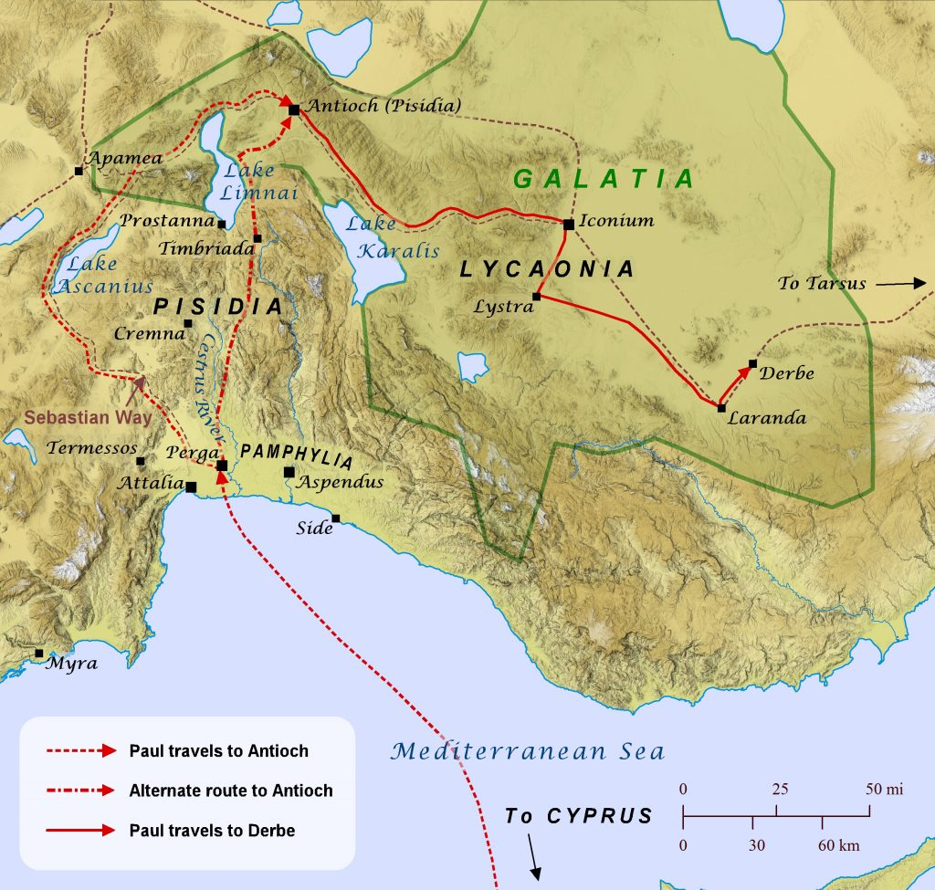

Verses 4 thru 7 (Faith Under Fire)‬‬‬‬‬
Paul’s preaching divides the city and a mob of Jews, Gentiles and the leaders of the town decide to kill Paul to stop the spread of the gospel. Paul and Barnabas learn about their murderous plot and they flea to the towns of Lystra and Derbe where they continue to preach the gospel message.
Verses 8 thru 10 (Stand Up!)‬‬‬‬‬
While Paul was in the town of Lystra, he finds a man who had been crippled his entire life. The main purpose of their ministry was to preach the gospel, but having the power of the Holy Spirit in them, also allowed them to heal people and cast out demons. This crippled man had heard the gospel message and received it with joy. Paul sees the man in his crippled state, and Paul knows that he has received Christ in his heart. Paul new that he had the faith to be healed, so he simply tells the man to “Stand Up”. Not only did the man who had never walked stand up, but we are told that he jumped up and started walking immediately. He did not believe because he was healed, but rather he was healed because he believed!
Verses 11 thru 18 (Misguided Faith)‬‬‬‬‬
When the people of Lystra saw this great miracle, they assume that Paul and Barnabas must be gods in human form. Most of the Gentiles in this area were Greek and in that culture, there was a belief that the gods would come down to Earth and take on the appearance of mortals to test the humans. They call Paul Hermes (Mercurius KJV) and they called Barnaba Zeus (Jupiter KJV). There was a legend in that area that Zeus and Hermes had come down to Earth as beggars and only two old peasants were kind to them. Because the rest of the town had not been kind to them, the gods destroyed the entire town except for the two old peasants. Knowing this legend probably helps to understand what the crowd does next.
The people of the city decided that they would sacrifice bulls to these two gods. They made flower wreaths to recognize Paul and Barnabas so the town would not be destroyed. Paul and Barnabas plead with the people not to do such a wicked thing and tell them that they are just mortal men the same as they are. They continue to preach to the crowd and tell them to turn from these useless things, turn to God and repent of their sins. Many people who are attending church for the first time can have similar thoughts and not know how to understand what is going on in our services. Make sure to take the time to get to know these new people and answer any questions that they may have. Whether it’s placing rocks in a jar, speaking in tongues or quoting Psalms 19:14 at the end of the service, be ready to engage with new believers and help them to feel comfortable in our services.

Verses 19 and 20 (Suffering for the Gospel)‬‬‬‬‬
Remember in chapter 13 when the Jews from Antioch forced Paul and Barnabas to leave town? Remember the Jews who attempted to stone Paul in verse 6? Well, those same Jews from Iconium and Antioch have now followed these missionaries to Lystra and they stir up the crowd against them again. This time they drag Paul out of town and stone him. They probably thought that they had killed him, but Paul miraculously survives and goes back into town. Would you have gone back into a town full of people who just tried to kill you? Paul would later talk about his suffering for preaching the gospel in 2 Cor. 11:25 and he would say that he was beaten 3 times, stoned, shipwrecked and spent a full day and night adrift in the ocean. What have you suffered for Christ? We should count it all joy when we suffer for Christ.
Verses 21 thru 28 (Completing the Mission)‬‬‬‬‬
Paul and Barnabas leave Lystra and go to Derbe, the last town on this missionary journey. After winning many souls to Christ in Derbe, they decide to go back and visit all of the other towns where they had started churches. As they stopped by these churches, they encouraged these new believers to continue to grow in Christ and they appointed elders in every church. This entire first missionary journey had taken less than two years. So how were these “babies” in Christ able to run a church and teach about Christ?
These new churches were probably a little unorganized and needed some structure. By appointing leaders in these new churches, Paul leaves elders in charge of growing and teaching the new believers. Paul spends some additional time with each elder in prayer and fasting seeking the will of God and preparing them for their ministry. As Paul had already found out, he warns these churches that they would have to endure many hardships to enter the kingdom of God.
A few years later, Paul would here about how the Jews were trying to get the Christians to return to the Jewish laws. He would write a scathing letter to the Galatians for returning to the Law after accepting Jesus in the hope that they would not fall away from the faith. Paul would later return to Galatia on his second missionary journey and spend time strengthening the believers in these churches.
After Paul finishes his work in these new churches, he returns to Perga. There they would board a ship and return to Antioch of Syria from where the journey had began. After returning to his home church, Paul shared the wonderful news about the churches he had started and how the Gentiles had accepted the Good News. Paul would stay in Antioch of Syria for several years before he is sent on his next mission back to Jerusalem.
Read Chapter 15 before our next class.

